**Development of**

**Supply Chain Management System for Bakery Products**

A Practicum Report Submitted by

**Md Shahriair Alam**

**ID: 20103204**

In the Partial Fulfillment of the Requirements

for the Award of Bachelor of Computer Science and Engineering (BCSE)



Department of Computer Science and Engineering

College of Engineering and Technology

IUBAT – International University of Business Agriculture and Technology

Fall 2023

Supply Chain Management System for Bakery Products

Md Shahriair Alam (20103204)

A Practicum Report Submitted in the Partial Fulfillment of the Requirements for the Award of Bachelor of Computer Science and Engineering (BCSE)

The thesis has been examined and approved,

**Prof Dr. Utpal Kanti Das**Chairman & Professor   
Dept. of Computer Science and Engineering  
IUBAT – International University of Business Agriculture and Technology

**Rashedul Islam**Co-supervisor, Coordinator and Assistant Professor  
Dept. of Computer Science and Engineering  
IUBAT – International University of Business Agriculture and Technology

___________________________

**Tasnia Anjum Rifah**Supervisor and Lecturer  
Dept. of Computer Science and Engineering  
IUBAT – International University of Business Agriculture and Technology

Fall - 2023

# Letter of Transmittal

19 October 2023

The Chair

Practicum and Placemen Board

Department of Computer Science and Engineering

IUBAT–International University of Business Agriculture and Technology

4 Embankment Drive Road, Sector 10, Uttara Model Town

Dhaka 1230, Bangladesh

**Subject:** Letter of Transmittal.

Dear Sir,

With due respect, I would like to inform you that it is a great pleasure and a great pleasure for me to submit this report entitled “**Development of Supply Chain Management System for Bakery Products**” to complete my Practicum course.

It was a great opportunity for me to work on this project to make my theoretical knowledge more realistic and I gained a lot of exposure to the business culture of a famous company. I now look forward to your kind commentary on this performance report.

I will always be very grateful to you if you kindly go through this report and check my performance.

Sincerely Yours,

_____________

Md Shahriair Alam

20103204

# Organization Certificate

# Student’s Declaration

I am Md Shahriair Alam, is student of the BCSE-Bachelor of Computer Science and Engineering program, under the College of Engineering and Technology (CEAT) of the International University of Business Agriculture and Technology (IUBAT) announcing this report entitled **“Development of Supply Chain Management System for Bakery Products”** has been prepared for the completion of the practicum course, which is part of the Bachelor of Computer Science and engineering degree.

The report of **“Development of Supply Chain Management System for Bakery Product”** was edited by me. All modules and procedures for this research are done after proper testing and online information.

It is not designed for other purposes, awards or presentations.

_____________

Md Shahriair Alam

20103204

# Supervisor’s Certification

This is to ensure that the practicum report on the **“Development of Supply Chain Management System for Bakery Products”** is compiled by Md Shahriair Alam, with ID #20103204, of IUBAT– International University of Business Agriculture and Technology, as part of the fulfillment of the required part of an effective practicum course. The report has been prepared under my supervision and is a record of the work accomplished, successfully completed. To the best of my knowledge and as per there declaration, no portions of this report have been posted anywhere by any degree, diploma or certificate.

You are now allowed to submit a report. I wish your every success in the future endeavors.

Practicum Supervisor

_______________________________

Tasnia Anjum Rifah

Lecturer

Department of Computer Science and Engineering

IUBAT–International University of Business Agriculture and Technology

# Abstract

The **Supply Chain Management System for Bakery Products** is a sophisticated and comprehensive platform meticulously developed on the Laravel framework, incorporating a robust SQL database backend. This advanced system is designed to cater to a diverse spectrum of stakeholders, encompassing six key user roles: Administrator, Supplier, Manufacturer, Distributor, Retailer, and End User Customer. Administrators wield extensive control over system settings and user management, ensuring the smooth operation of the entire platform. Suppliers play a crucial role in managing the seamless supply of raw materials to Manufacturers, facilitating a streamlined production process. Manufacturers, in turn, leverage the system for a multitude of functions, including placing orders for raw materials, overseeing production processes, and maintaining a well-organized inventory. The platform extends its functionality to Distributors and Retailers, empowering them to efficiently handle the distribution of bakery products and manage local inventory effectively. For End User Customers, the system offers an intuitive and user-friendly website experience. Customers can peruse an extensive array of bakery products, place orders seamlessly, and conveniently execute online payments through the SSL Commerz option, tailored specifically to meet the needs of users in Bangladesh. One notable feature of the system is its meticulous attention to detail, providing transparent visibility across the entire bakery supply chain. This ensures a seamless and optimized process for all stakeholders involved, fostering efficiency, transparency, and collaboration throughout the entire supply chain.

# Acknowledgments

Firstly, I want to give Almighty Allah to our sincere gratitude for His wonderful grace, which enabled me to successfully finish the thesis.

I would like appreciate and acknowledge all the people who has encouraged and supported me through the entire journey and has played a great role the completion of my Practicum and the report on “**Development of Supply Chain Management System for Bakery Product**”. First of all I would like to thank Almighty for uncountable and beyond to words reasons and for giving me the power to stay motivated all the time for completing any task. I want to thank my parents, who have endowed their immeasurable support and encouragement to attain this exquisite event of my life.

I would like to convey sincere thanks to our Vice Chancellor **Dr. Abdur Rab** for giving me an opportunity to submit this report. My outmost and sincere gratitude goes to **Prof. Dr. Utpal Kanti Das**, Chairman of Department of Computer Science and Engineering and **Rashedul Islam**, Coordinator of Department of Computer Science and Engineering for allowing me to work on the project.

I would like to thank our academic supervisor, **Tasnia Anjum Rifah**, Lecturer of the Department of Computer Science and Engineering of IUBAT-International University of Business Agriculture and Technology, who has encouraged me throughout the entire time and has provided me with all the necessary guidelines and support that I needed.

At last, I would like to thank Tohidul Islam (Technical Lead, Kodeeo Limited) for giving me the opportunity to complete my internship and project at Kodeeo Limited.

Table of Contents

Letter of Transmittal iv

Organization Certificate v

Student’s Declaration vi

Supervisor’s Certification vii

Abstract viii

Acknowledgments ix

List of Tables 5

List of Figures 6

Chapter I. About Organization 8

1.1 Organization Overview 8

1.2 Organizational Service 8

1.2.1 Software Development 8

1.2.2 Website Development 9

1.2.3 Mobile App Development 9

1.2.4 Domain and Hosting 10

1.3 Clients of the Organization 10

1.4 Organizations Expertise and Goals 10

1.5 Organizational Mission 11

1.6 Organization Vision 11

1.7 My Position in the Organization 11

1.8 Organization Structure 12

Chapter 2. Project Introduction 13

2.1 Introduction 13

2.2 Project Overview 13

2.3 Objectives 14

2.4 Scope of the project 14

2.5 Methodology 15

2.5 Limitation of the project 15

2.6 Process model 15

2.6.1 The reason for Incremental Process Model 16

2.7 Feasibility Study 17

2.7.1 Technical Feasibility 17

2.7.2 Economic Feasibility 18

2.7.3 Operational Feasibility 18

Chapter 3. Requirement Engineering 19

3.1 Requirement Analysis 19

3.2 Requirement Engineering 19

3.2.1 User Requirements 19

3.3.2 System Requirements 22

3.2.3 Functional Requirements 28

3.2.4 Non-Functional Requirements 31

Chapter 4. System Planning 34

4.1 Functions of the System 34

4.2 Project Planning 35

4.2.1 Project Estimation 35

4.2.2 Function Oriented Metrics 35

4.2.3 Function Point Estimation 36

4.2.4 Task Distribution/Scheduling 40

4.2.5 Scheduling Chart 41

4.2.6 Cost Estimation 41

Chapter 5. Risk Management 45

5.1 Risk Management Process 45

5.2 Risk Management Implementation 46

5.3 The RMMM Plan 47

5.4 The Risks are: 47

5.4.1 Technical Risks 47

5.4.2 People Risks 48

5.4.3 Estimation Risks 48

5.4.4 Requirements Risks 49

5.4.5 Tools Risks 49

Chapter 6. Analysis Modeling 51

6.1 Analysis Modeling 51

6.1.1 Goals of the Analysis Model 51

6.2 Activity Diagram 51

6.2.1 Activity Diagram of Admin 52

6.2.2 Activity Diagram of Manufacturer 52

6.2.6 Activity Diagram of Customer 56

6.3 Entity Relationship Diagram (ERD) 56

6.4 Data Flow Diagram (DFD) 58

6.4.1 Context Level DFD 58

6.4.2 Level 1 DFD 59

6.4.3 Level 1 DFD of Process 1 60

6.4.4 Level 1 DFD of Process 2 61

6.4.5 Level 1 DFD of Process 3 62

6.4.6 Level 1 DFD of Process 4 62

6.4.7 Level 1 DFD of Process 5 63

6.4.8 Level 1 DFD of Process 6 63

Chapter 7. Designing 64

7.1 Database Field Design 64

7.2 Interface Designing 67

Chapter 8. Quality Assurance 73

8.1 Software Testing 73

8.2 Software Testing Strategy 73

8.3 Testing Design 75

Chapter 9. Conclusion 78

9.1 Preface 78

9.1.1 Practicum and Its Value 78

9.2 Conclusion 79

9.3 Limitations 80

9.4 Future Plan 80

Glossary 81

References 82

# List of Tables

Table 4.2 Identifying Complexity (Transaction Function) 36

Table 4.3 Identifying Complexity (Data Function) 37

Table 4.4 Unadjusted Function Point Contributions (Transaction Function) 38

Table 4.5 Unadjusted Function Point Contribution (Data Function) 38

Table 4.6 Total Degree of Influence 39

Table 4.7 Scheduling Chart 41

Table 4.8 PersonnelCostTable 42

Table 4.9 Hardware cost 43

Table 4.10 Software cost 43

Table 4.11 Other cost 43

Table 4.12 Total Development Cost 44

Table 5.1 Technical Risk (1) 47

Table 5.2 Technical Risk (2) 47

Table 5.3 People Risk 48

Table 5.4 People Risk (2) 48

Table 5.5 Estimation Risk (1) 49

Table 5.6 Estimation Risk (2) 49

Table 5.7 Requirements Risk 49

Table 5.8 Tools Risk 50

Table 8.1 Testing Scenario 1 75

Table 8.2 Testing Scenario 2 75

Table 8.3 Testing Scenario 3 76

Table 8.4 Testing Scenario 4 76

Table 8.5 Testing Scenario 5 76

# List of Figures

Figure 1.1 Organization Structure 12

Figure 2.1 Incremental Process Model 16

Figure 3.1 Use Case Diagram 32

Figure 6.1 Activity Diagram of Admin 52

Figure 6.2 Activity Diagram of Manufacturer 53

Figure 6.3 Activity Diagram of Supplier 54

Figure 6.4 Activity Diagram of Distributor 54

Figure 6.5 Activity Diagram of Retailer 55

Figure 6.6 Activity Diagram of Customer 56

Figure 6.7 Entity Relationship Diagram 57

Figure 6.8 Level 0 DFD 58

Figure 6.9 level 1 DFD 59

Figure 6.10 Level 1 DFD of Process 1 60

Figure 6.11 Level 1 DFD of Process 2 61

Figure 6.12 Level 1 DFD of Process 3 62

Figure 6.13 Level 1 DFD of Process 4 62

Figure 6.14 Level 1 DFD of Process 5 63

Figure 6.15 Level 1 DFD of Process 6 63

Figure 7.1 List of Database tables 64

Figure 7.2 Structure of Users table 64

Figure 7.3 Structure of Roles table 65

Figure 7.4 Structure of Permissions table 65

Figure 7.5 Structure of Products table 66

Figure 7.6 Structure of Raw Materials table 66

Figure 7.7 Structure of Customers table 66

Figure 7.8 Structure of Carts table 66

Figure 7.9 Structure of Orders table 67

Figure 7.10 Structure of Order details table 67

Figure 7.11 System User Login interface 67

Figure 7.12 System User Dashboard interface 68

Figure 7.13 Materials page interface 68

Figure 7.14 Products page interfac 68

Figure 7.15 Users page interface 69

Figure 7.16 Roles and Permissions page interface 69

Figure 7.17 Website interface 70

Figure 7.18 Customer Registration page interface 70

Figure 7.19 Customer Log interface 71

Figure 7.20 Shopping Cart interfac 71

Figure 7.21 Customer profile interface 72

# Chapter I. About Organization

## 1.1 Organization Overview

Kodeeo Limited, located in Bangladesh, is a software development company specializing in IT consulting and services. The company excels in software development, website and mobile application design and development, as well as the implementation of e-commerce solutions. With a track record spanning four years, Kodeeo Limited has successfully executed projects of varying sizes, catering to end users, businesses, organizations, associations, and governmental entities.

The company's approach revolves around understanding and meeting client requirements. By deploying its professional team and strategic planning, Kodeeo Limited consistently achieves goals and objectives for the client's benefit. This approach is guided by a win-win mindset, unwavering commitment, and thorough planning to directly enhance customer outcomes. The seasoned professionals at Kodeeo Limited bring years of experience to the table, delivering client-centric solutions with a targeted focus.

## 1.2 Organizational Service

Kodeeo Limited offers a diverse range of services to its clients. The primary services rendered by Kodeeo Limited include:

* Software Development
* Mobile App Development
* Website Development
* E-commerce Website
* ERP
* Domain and Hosting

#### 1.2.1 Software Development

A functional software or web application benefits businesses of all sizes to run better through digital transformation and modern capabilities. Kodeeo Limited plans, designs, develops, tests, deploys and maintains software and web applications to drive efficiency and effectiveness.

For building efficient and client satisfactory software’s Kodeeo Limited has the followings,

* Custom development, integration, migration, and maintenance programs are offered both in the cloud and on-premises. This includes creating connected mobile applications on iOS and Android platforms that use both native and cross-platform technologies.
* Knowledge of certified and trained engineers specializing in well-known cloud platforms such as AWS.
* Implementation of DevOps workflow automation, continuous integration and deployment pipelines and knowledge of micro services architecture and docking.
* Providing automated and manual software testing services for both software and products. Kodeeo Limited has been actively engaged in conceiving, structuring, and delivering technology and business solutions to its clientele.

#### 1.2.2 Website Development

A company's online identity is encapsulated in its website. Websites play a pivotal role in enhancing brand or product awareness, ultimately influencing sales and brand recognition based on the company's objectives. Serving as a global introduction, a website shapes the company's image, fost

Kodeeo Limited specializes in constructing effective websites designed to increase search engine traffic. This involves creating fast-loading web pages with intuitive navigation and compelling design elements, facilitating more impactful global communication. Whether a company seeks a dynamic or static site, Kodeeo Limited is well-equipped to provide the desired solution.

Tailoring solutions to meet specific client requirements, Kodeeo Limited ensures the development of websites that effectively target potential customers, establishing a dynamic online presence for the company.

#### 1.2.3 Mobile App Development

To ensure the success of a mobile app, it is crucial to evaluate objectives and consider the broader perspective. Kodeeo Limited enhances its clients' global reach by crafting and developing intuitive native mobile applications optimized for various operating systems such as Android and Windows.

Kodeeo Limited stands out for its proficiency in expanding user bases and formulating growth strategies, leveraging advanced machine learning processes that primarily focus on user behavior. This approach yields valuable insights for optimization and enhancement.

With a rich portfolio, Kodeeo Limited has collaborated on diverse projects, including B2B networking platforms, live tracking applications, delivery systems, event registration portals, and more. The development of top-tier mobile apps is facilitated by a team of individuals boasting over a decade of experience.

#### 1.2.4 Domain and Hosting

Think of a domain name as your distinct online identity, much like how each person in your phone agenda has a unique name associated with their phone number. Remembering numerous phone numbers can be daunting, just as recalling specific IP addresses for websites is impractical. In essence, a domain name functions as a comprehensive online directory. When you input a company's URL or domain name, your browser communicates with the hosting provider's DNS server to fetch the website's IP address. This IP address, comparable to a phone number, allows your brows

At Kodeeo Limited, we pride ourselves on offering budget-friendly domain and hosting services, ensuring our clients have seamless access to these fundamental components for establishing and maintaining a robust online presence.

## 1.3 Clients of the Organization

The list of clients of Kodeeo Limited software company:

* Data Bangla
* Municipal Association of Bangladesh (MAB)
* WABMART Limited
* Barakah Fresh (Pvt.) limited
* Courier Bengal
* Bakeboss
* Directorate General of Drug Administration DGDA

## 1.4 Organizations Expertise and Goals

Kodeeo Limited clearly defines its objectives across essential parameters and adheres to established processes and standards to consistently measure and achieve success, remaining focused on the target. Each team member firmly believes there is no alternative approach. The elevated customer appreciation rating for Kodeeo Limited is indicative of their consistent delivery on these vital parameters.

The company excels in strengthening existing relationships, forging new ones, and venturing into unexplored markets. Collaborations with alliance partners extend Kodeeo Limited's reach into markets where they lack a direct presence. Clients can trust Kodeeo Limited to be their comprehensive partner in the respective field of expertise. The enduring vision of Kodeeo Limited is, and always will be, to contribute to the success of their clients.

## 1.5 Organizational Mission

At Kodeeo Limited, we utilize our technical proficiency and expertise to combine graphic design, web page architecture, interactive design, and database content. This integration allows us to strategize, construct, and implement e-business solutions, positioning us as a leading IT service provider.

## 1.6 Organization Vision

We are dedicated to turning imagination into reality! At Kodeeo Limited, we strive to establish enduring relationships with our clients, aspiring to be the future partners in their success. Our focus is on surpassing competitors by prioritizing customer engagement and commitment over the formulation of grand vision statements.

## 1.7 My Position in the Organization

I am currently interning in the website development division at Kodeeo Limited, where I report to Md Tohidul Islam. He is a gentle and humble individual who consistently tackles challenges with a unique perspective, emphasizing the importance of thinking outside the box for generating original ideas. My internship experience at Kodeeo Limited has been exceptionally positive, with a welcoming work environment and effective collaboration among team members. Being part of this organization has provided me with valuable opportunities to acquire new knowledge, and I am delighted to have the chance to intern at such a well-regarded company.

## 1.8 Organization Structure

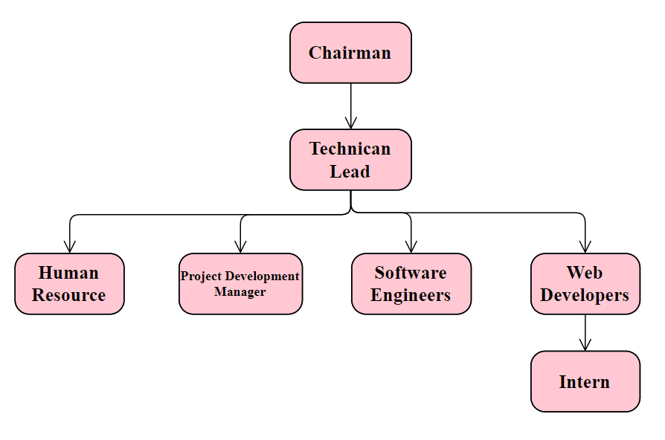

Figure 1.1 Organization Structure

# Chapter 2. Project Introduction

## 2.1 Introduction

In the ever-evolving landscape of the bakery industry, where precision and efficiency are paramount, the adoption of a well-designed Supply Chain Management (SCM) system emerges as a strategic necessity. Bakeries, facing the dual challenges of fluctuating ingredient costs and the need to stay agile in response to dynamic market trends, find themselves at a crossroads. Conventional methods, often manual or lacking in organization, can result in operational inefficiencies and increased financial burdens.

This project report is dedicated to exploring the imperative of introducing a tailored SCM system in bakery operations. The primary focus is to optimize processes seamlessly, encompassing procurement, production, and distribution, ultimately leading to improved operational efficiency and the ability to meet the heightened demands of the market

The report will thoroughly examine the project's objectives, delving into the key components of the proposed SCM system, exploring opportunities for technology integration, and projecting the anticipated benefits for bakery operations. By simplifying complex processes and harnessing the power of practical technology solutions, this project aspires to empower bakeries, enabling them to navigate challenges adeptly and meet consumer expectations with ease in the competitive bakery market. Throughout the report, emphasis will be placed on the simplicity and practicality of the proposed SCM system to make it accessible and beneficial for bakery stakeholders at all levels.

## 2.2 Project Overview

The Supply Chain Management System (SCMS) project is designed to manage the way organizations based on their supply chain processes. In the contemporary business landscape, characterized by globalization, the SCMS aims to enhance efficiency, transparency, and collaboration manner within the supply chain. The primary objectives of the project include improving operational efficiency, providing real-time visibility into the entire supply chain, fostering collaboration among stakeholders, enabling data-driven decision-making, and automating routine processes. Key features of the SCMS encompass supplier management, inventory optimization, order tracking and fulfillment, collaborative planning, data analytics, and reporting, as well as security and compliance measures. By implementing the SCMS, organizations anticipate cost reduction, improved customer satisfaction, strategic decision-making capabilities, and increased agility to adapt to dynamic market conditions. Ultimately, the SCMS project seeks to create a flexible and adaptable supply chain system that aligns with the evolving needs of businesses in today's complex environment.

## 2.3 Objectives

The central aim of the Supply Chain Management System Project is to effectively handle the details pertaining to Customer, Product, Order, and Shipment. It comprehensively manages information related to Customer, Delivery, and Product. The project is exclusively constructed for administrative use, ensuring that only the administrator has guaranteed access. Its overarching goal is to develop an application program that reduces manual efforts in handling Customer, Product, Delivery, and Product Company details. The system meticulously tracks information about Product Company, Order, and Shipment.

The key points of this project encompass:

* Enhancing the efficiency of procurement processes to ensure the timely and cost-effective of raw materials.
* Optimizing planning and scheduling to improve resource utilization and minimize time.
* Strengthening relationships with suppliers through the implementation of a collaborative Supplier Relationship Management (SRM) platform.
* Improving distribution and logistics to guarantee timely and cost-efficient product delivery.

## 2.4 Scope of the project

It can facilitate the meticulous gathering of detailed management information, ensuring a clear, straightforward, and meaningful collection in a short period. This aids individuals in gaining a precise and vivid understanding of the past year's management. Furthermore, it supports ongoing tasks related to the Supply Chain Management System, contributing to streamlined and cost-effective management collection procedures

Our project is centered on Business Process Automation, signifying our efforts to automate various aspects of the Supply Chain Management System. Within a computerized system, individuals are required to fill out various forms, and multiple copies of these forms can be easily generated simultaneously. Additionally, the computer system eliminates the need to manually create manifests; instead, they can be directly printed, saving valuable time. The project's objectives include assisting staff in capturing efforts in their respective work areas, enhancing resource utilization through automation for increased productivity. The system generates various types of information that can be utilized for diverse purposes, satisfying user requirements with an easy-to-understand interface for both users and operators. The system is designed to be easy to operate, possess a good user interface, be expandable, and be delivered on schedule within the specified budget.

## 2.5 Methodology

The creation of the "Supply Chain Management System" has followed an incremental model, aligning with the structural framework outlined in Software Analysis and Design. This preliminary study on the development of the Supply Chain Management System emphasizes its early stages, with a focus on establishing a foundational understanding of the system's structure and functionality. The incremental approach adopted in the development process ensures a systematic and iterative enhancement of the system, aligning with best practices in software engineering for a comprehensive and effective Supply Chain Management System.

## 2.5 Limitation of the project

As mentioned earlier in this report, an internship serves as a bridge connecting theoretical knowledge to practical application. The internship program at IUBAT has provided me with a valuable opportunity to witness the translation of theory into real-world practice. Initially, upon joining the organization, I encountered numerous conditions and systems that were unfamiliar to me. Over time, however, I have become accustomed to these terms and have learned from the experiences of older classmates and friends who have undergone similar adjustments. It's important to note that a limitation of this internship project is the constraint of time. Developing comprehensive software within a short timeframe is a challenging task, even with the application of software engineering techniques. Consequently, the scope of the internship project had to be narrowed due to these time constraints.

## 2.6 Process model

I chose incremental process model to develop this project. The Incremental Process Model is a software development methodology that prioritizes breaking down the development process into smaller, manageable parts called increments. Each increment shows a part of the overall system operation and is developed separately. The development team works on one increment at a time, delivering a partial system that can be tested and integrated into the existing system. This approach allows us for continuous development, testing, and refinement of the software in incremental steps.

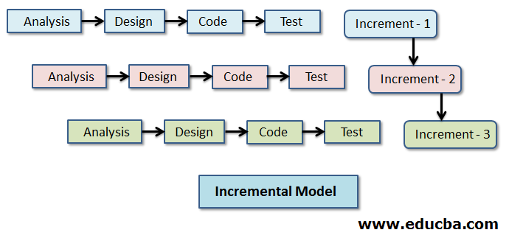

Figure 2.1 Incremental Process Model

#### 2.6.1 The reason for Incremental Process Model

The Incremental Process Model offers several advantages in the software development lifecycle, contributing to a more flexible and adaptive approach. Here are some key advantages:

* Early Delivery: Provides functional parts of the system early in the development process.
* User Feedback: Facilitates continuous user feedback and involvement throughout development.
* Risk Reduction: Smaller increments reduce the overall risk of project failure.
* Flexibility: Adaptable to changing requirements, allowing easy incorporation of modifications.
* Testing Efficiency: Focused testing on specific functionalities simplifies identification and resolution of issues.
* Early Core Features: Core functionalities can be implemented early, forming a foundation for subsequent increments.
* Client Satisfaction: Regular delivery of usable features enhances client satisfaction.
* Resource Optimization: Efficient use of resources as teams focus on specific, manageable increments.

## 2.7 Feasibility Study

A feasibility study involves a comprehensive assessment and analysis to determine the practicality, viability, and potential success of a proposed project or business venture. This evaluation takes place before the project initiation to assess its merit. The study's objective is to equip stakeholders, including investors, management, and decision-makers, with the essential information required to make informed decisions about pursuing the project.

There are three main feasibility studies are:

* Technical feasibility
* Economic feasibility
* Operational feasibility

#### 2.7.1 Technical Feasibility

Technical feasibility involves evaluating whether a proposed project or system can be successfully developed and implemented using available technology and resources. This assessment focuses on key aspects such as technology requirements, the expertise and skills of the project team, compatibility with existing systems, identification of potential technical risks, estimation of technology costs, and the availability of technical support for ongoing maintenance. A positive technical feasibility analysis suggests that the project can be effectively executed from a technological standpoint, while any identified challenges may prompt adjustments to the project scope, technology choices, or resource allocation. Technical feasibility is a crucial consideration in the overall feasibility study conducted before committing resources to a project.

**Hardware/Software Requirements:**

* Operating System (Windows 7 or more)
* Ram (4 GB or more)
* Web Browser (chrome or any suitable one)

**Developing Tools**

* Composer
* Visual Studio code
* PHP (Laravel Framework)
* XAMPP Server (MySQL)

#### 2.7.2 Economic Feasibility

The objective of an economic feasibility evaluation is to ascertain the favorable economic advantages that a proposed system will bring to an organization. Our system demonstrates economic viability as it enables the completion of numerous tasks in a short time, tasks that cannot be simultaneously achieved by human efforts. Additionally, the system diminishes the workforce needed to manage products, order details, customer information, and payment details. Consequently, if the existing system demands a significant number of employees, the expenses associated with personnel decrease, resulting in cost savings.

#### 2.7.3 Operational Feasibility

Operational feasibility involves evaluating whether a proposed project or system can be seamlessly integrated into an organization's current operations. This assessment examines the impact on daily activities, resource availability, training requirements for staff, alignment with organizational goals, user acceptance, legal compliance, scalability, and the development of a transition plan. The goal is to determine whether the proposed solution can be effectively implemented within the existing operational framework, minimizing disruptions and ensuring a smooth integration. A positive operational feasibility assessment indicates that the proposed project is likely to be operationally successful and align with the organization's strategic objectives. Identified challenges may necessitate adjustments to the project plan or a reevaluation of the proposed solution.

# Chapter 3. Requirement Engineering

## 3.1 Requirement Analysis

The requirement analysis serves as a tool for the software designer to convert data, architectural, interface, and component level designs into information, function, and behavior. The completion of requirement analysis occurred during the task phases outlined in this chapter.

## 3.2 Requirement Engineering

Requirements engineering, as implied by its name, is a branch within engineering dedicated to the development of software systems and the identification of user needs. While various definitions exist for requirements engineering, they all converge on the idea that it revolves around comprehending user expectations for a computer system and deciphering the implications of these requirements on the design. This field shares close ties with software engineering, which principally concentrates on the process of constructing systems aligned with customer preferences.

The following requirements will be covered in this project-

* User requirements
* System requirements
* Functional requirements
* Non-Functional requirements

#### 3.2.1 User Requirements

The Supply Chain Management System has 6 types of users,

1. Admin
2. Supplier
3. Manufacturer
4. Distributor
5. Retailer
6. Customer

The user requirements of the project Supply Chain Management System are as follows:

**Admin**

1. Admin can login to the system by username and password. Admin does not need to register to the system.
2. Admin can add other users and delete them.
3. Admin can assign permissions to the users.
4. Admit can add raw materials, products and also can delete and edit them.
5. Admin can manage category and unit of products.
6. Admin can see order status and recently placed order list.
7. Admin can generator reports for every section.

**Supplier**

1. Supplier can login to the system by user name password and doesn't need to register.
2. Supplier can see the product list but cannot update them.
3. Supplier can add, edit and delete raw materials.
4. Supplier can receive order of raw materials from the manufacturer.
5. Supplier can generate the report only for raw materials.
6. Supplier can manage unit of raw materials.
7. Supplier can see other users but cannot delete and edit them.

**Manufacturer**

1. Manufacturer can login to the system by username and password.
2. Manufacturer can see the raw materials list but cannot delete and edit them.
3. Manufacturer can place order to the supplier for the raw materials.
4. Manufacture can see the stock of raw materials.
5. Manufacturer can see the other users but cannot update them.
6. Manufacture can generate report only for the raw materials.
7. Manufacturer can upload the product, edit and delete them, also can manage the category.

**Distributor**

1. Distributors can login to the system by using username and password.
2. Distributors can add products, edit and delete them.
3. Distributor can manage product category and the report of products.
4. Distributor will get task from manufacturer.
5. Distributor will reach products to the retailer.

**Retailer**

1. Retailer can login to the system by username and password.
2. Retailer can see the raw materials but cannot edit and delete them.
3. Retailer can receive the order of bakery products from the customer.
4. Retailer can add product and edit and delete them.
5. Retailer can manage the payment of customer.
6. Retailer can generate the report.
7. Retailer can delete the registered customer.
8. Retailer can add the delivery man, also delete them and assign task for delivery the products to the customer.

**Customer**

1. Customer can visit website and can see the all of category of products.
2. Customer can register and login to the system.
3. Customer can view the products.
4. Customer can place order and make payment.
5. Customer can track the delivery man.
6. Customer care see the invoice and download the invoice.

#### 3.3.2 System Requirements

**Admin**

1. **Admin can login to the system by username and password. Admin does not need to register to the system**

1.1 There will have a special route for the admin login.

1.2 A form will be there for entering the username and password.

1.3 A button will be there below the form named “Sign in”.

1. **Admin can add other users and delete them.**

2.1 There will be a button called users in the side bar of admin dashboard.

2.2 Beside every user there have a button called Delete.

* 1. Also there will have button for adding new users called Add Users.

1. **Admin can assign permissions to the users.**

3.1 There will be a button called “All Roles” in the sidebar under the Users dropdown**.**

3.2 There for every role admin can assign specific permissions to the specific role.

**4. Admit can add raw materials, products and also can delete and edit them.**

4.1 In the site bar there will be a button named Raw Materials.

* 1. In the raw materials page there will be button Add Raw Materials.

4.3 For each raw material there will have button named View, Edit and Delete.

* 1. Also in the site bar there will be a button named Products.

4.5 In the raw products page there will be button Add Products

4.6 For each product there will have button named View, Edit and Delete.

**5. Admin can manage category and unit of products.**

4.1 In the sidebar there will have a button name Manage Category.

4.2 Also in the sidebar there will be a button for unit’s name Manage Units.

* 1. Beside each unit and category name there will be two button icon of edit and delete.

**6. Admin can see order status and recently placed order list.**

5.1 In the admin dashboard there will be a portion for displaying the recently place

order list.

* 1. Also beside the order list, order status will be visible there.

**7. Admin can generator reports for every section.**

6.1 In the sidebar there will have button named Report.

6.2 Also there will be a button beside every section named Generate Report.

**Supplier**

1. **Supplier can login to the system by user name and password and doesn't need to register.**

1.1 Supplier will login to the system by the same route which is used by

the admin but username and password will not be same.

1.2 A form will be there for entering the username and password.

* 1. A button will be there below the form named “Sign in”.

1. **Supplier can see the product list but cannot update them.**

2.1 There will be a button on in the side named Products.

2.2 Beside every product there will be a button called View.

2.3 But there will be no button for editing and deleting.

1. **Supplier can add, edit and delete raw materials.**

3.1 In the site bar there will be a button named Raw Materials.

3.2 In the raw materials page there will be button Add Raw Materials.

* 1. For each raw material there will have button named View, Edit and Delete.

1. **Supplier can receive order of raw materials from the manufacturer.**

4.1 There will be a button named Orders in the sidebar.

4.2 In the order page there will have the details of order and users.

4.2 In the order section there will be for payment status to check the payment.

1. **Supplier can generate the report only for raw materials.**

5.1 There will be a button in the side burn named Report.

5.2 There will have only option of Raw Materials for generating the reports.

1. **Supplier can manage unit of raw materials.**

6.1 In the sidebar there will be a button for unit’s name Manage Units.

6.2 Beside each unit name there will be two button icon of edit and delete.

1. **Supplier can see other users but cannot delete and edit them.**
   1. There will be a button called users in the side bar of dashboard.
   2. Also there will have no button for adding new users and delete them.

**Manufacturer**

1. **Manufacturer can login to the system by username and password.**

1.1 Manufacturer will login to the system by the same route which is used by

the admin but username and password will not be same.

* 1. A form will be there for entering the username and password.

1.3 A button will be there below the form named “Sign in”.

1. **Manufacturer can see the raw materials list but cannot delete and edit them.**

2.1 There will be a button on in the side named Raw Materials.

2.2 Beside every material there will be a button called View.

2.3 But there will be no button for editing and deleting.

1. **Manufacturer can place order to the supplier for the raw materials.**

3.1 There will be option in the raw materials page for entering the amount

of raw materials of placing order.

3.2 Also there will be a button below named Place Order.

1. **Manufacturer can see the stock of raw materials.**

4.1 There will be a button in the sidebar named Raw Materials.

4.2 Beside every raw material it is show the availability of stock.

1. **Manufacturer can see the other users but cannot update them.**
   1. There will be a button called users in the side bar of dashboard.
   2. Also there will have no button for adding new users and delete them.

**6. Manufacture can generate report only for the raw materials.**

6.1 There will be a button in the side burn named Report.

* 1. There will have only option of Raw Materials for generating the reports.

1. **Manufacturer can upload the product, edit and delete them, also can manage the category.**

8.1 In the site bar there will be a button named Products.

8.2 In the products page there will be button Add Products.

8.3 For each product there will have button named View, Edit and Delete.

**Distributor**

1. **Distributors can login to the system by using username and password.**

1.1 Distributor will login to the system by the same route which is used by

the admin but username and password will not be same.

* 1. A form will be there for entering the username and password.

1.3 A button will be there below the form named “Sign in”.

1. **Distributors can add products, edit and delete them.**

2.1 In the site bar there will be a button named Products.

2.2 In the products page there will be button Add Products.

3.3 For each product there will have button named View, Edit and Delete.

1. **Distributor can manage product category and the report of products.**

4.1 In the sidebar there will have a button name Manage Category.

4.2 Beside each category name there will be two button icon of edit and delete.

* 1. There will be a button in the side burn named Report.
  2. There will have only option of Products for generating the reports.

1. **Distributor will get task from manufacturer.**
   1. There will be a button called Tasks in the side bar of dashboard.
   2. After clicking the Tasks button, tasks will be appeared which is assign by the manufacturer.
2. **Distributor will reach products to the Retailer.**
   1. When Distributor will click the tasks button there will be address of retailer with

the tasks.

* 1. Distributor will confirm the delivery status to the manufacturer by clicking the

Confirm button.

**Retailer**

1. **Retailer can login to the system by username and password.**

1.1 Distributor will login to the system by the same route which is used by

the admin but username and password will not be same.

* 1. A form will be there for entering the username and password.

1.3 A button will be there below the form named “Sign in”.

1. **Retailer can see the raw materials but cannot edit and delete them.**

2.1 There will be a button on in the side named Raw Materials.

2.2 Beside every material there will be a button called View.

2.3 But there will be no button for editing and deleting.

1. **Retailer can receive the order of bakery products from the customer.**

3.1 There will be button in the sidebar called Orders

3.2 In the order page it is show all the orders and their details.

1. **Retailer can add product and edit and delete them.**

4.1 In the site bar there will be a button named Products.

4.2 In the products page there will be button Add Products.

4.3 For each product there will have button named View, Edit and Delete.

1. **Retailer can manage the payment of customer.**

5.1 There will be a button in the sidebar called Payment

5.2 In the payments there will be status for customer order, payment done or not.

1. **Retailer can generator the report.**

6.1 There will be a button in the sidebar named Report.

6.2 Also there would be a button beside every order list Generate report.

1. **Retailer can delete the registered customer.**

7.1 In the side bar there be a button called Customers.

7.2 In the user list page there will be a button named Delete only for the customer.

1. **Retailer can add the delivery man, also delete them and assign task for delivery**

**the products to the customer.**

8.1 There will be a button in the sidebar named Delivery.

8.2 In the delivery page there will be delivery list.

8.3 Also there will be a button called add delivery man.

8.4 Also there will have a button at task for the delivery.

**Customer**

1. **Customer can visit website and can see the all of category of products.**

1.1 There will be website which customer will visit.

1.2 Customer can visit all the categories of products by clicking the Category

button.

1.3 Category button will be available in the navigation bar of the website.

1. **Customer can register and login to the system.**

2.1 There will be a button in the top right navigation bar named Sign Up.

2.2 A form will be there for entering the full name, email, password and confirm

password.

2.3 A button will be there below the form named “Register”.

2.4 There will be a button in the top right navigation bar named Sign In.

2.5 A form will be there for entering the email and password.

2.6 A button will be there below the form named “Sign in”.

1. **Customer can view the products.**

3.1 In the navigation bar there will be button for Category, new arrivals and special

items.

3.2 Products will be show when customers will click the buttons.

1. **Customer can place order and make payment.**

4.1 There will a button for every product named “Add to Cart”.

4.2 Customer can add products by clicking add to cart button.

4.3 After that in the cart page there will be two option for payment: Cash on delivery

and online payment.

* 1. Customer can choose any of the payment method and place the orders.

1. **Customer can track the delivery man.**

5.1 There will be button of the customer profile named Delivery.

5.2 In the delivery page it will show correct status of delivery man.

1. **Customer care see the invoice and download the invoice.**

6.1 There will be a button in beside every approved order named “Download Invoice”

6.2 Customer can download the invoice by clicking the Download Invoice button.

#### 3.2.3 Functional Requirements

**Admin**

1. A login form will be open by visiting the specific url for the sysem users.
2. Admin can only log in by username and password.
3. When Admin click users button a drop down will come and their two option will be : All Roles and All users.
4. When Admin click add users then a form will come for adding the users.
5. For every role there will be a button edit. When admin will click edit button a modal will appear for adding the permissions.
6. When Admin will click add items, a form will open form adding items. When click edit button a pop up form will open for editing. When click delete button, a warning will come and say “Are You sure?”.
7. When admin click generate report button report will be download automatically.

**Supplier**

1. A login form will be open by visiting the specific URL for the system users.
2. Supplier can only log in by username and password.
3. When Supplier click products button all products will show but there will not be any button for edit and delete.
4. When Supplier will click Orders button, then a page will come which will provide all the orders lists, pending, and payment status. Supplier can approve and cancel orders by clicking the approve or cancel button.
5. When Supplier will click add items, a form will open form adding items. When click edit button a pop up form will open for editing. When click delete button, a warning will come and say “Are You sure?”.
6. When Supplier will click generate report button report will be download automatically.
7. When click Manage Units button then all the units will be shown. A pop up modal will be appear for editing and view units.
8. When Supplier click users button all users will show but there will not be any button for edit and delete users.

**Manufacturer**

1. A login form will be open by visiting the specific URL for the system users.
2. Manufacturer can only log in by username and password.
3. When Manufacturer click raw materials button, all materials will show but there will not be any button for edit and delete.
4. There will be add to cart button, when manufacture will click a pop up form will come for entering the quantity. Quantity will be more than one.
5. When Manufacturer will click cart button a cart page will come and there will be a option form updating the quantity. Also Manufacturer can remove the materials form the cart by clicking the remove button.
6. There will be two payment button, if Manufacturer clicks Cash on delivery then orders will be placed by providing all the shipping information.
7. If Manufacturer clicks online payment then a payment page will come for the online payment like Bkash, Nagad etc.

**Distributor**

1. A login form will be open by visiting the specific URL for the system users.
2. Distributor can only log in by username and password.
3. When Distributor will click add items, a form will open form adding items. When click edit button a pop up form will open for editing. When click delete button, a warning will come and say “Are You sure?”.
4. When click Manage Category button then all the categories will be shown. A pop up modal will be appear for editing and view categories.
5. When Distributor clicks the tasks button then one page will come the task lists. Distributor will get the address of retailer. Also Distributor can confirm to the Manufacturer, that delivery is completed by clicking the confirm button.

**Retailer**

1. A login form will be open by visiting the specific URL for the system users.
2. Retailer can only log in by username and password.
3. When Retailer click raw materials button, all materials will show but there will not be any button for edit and delete.
4. When Retailer will click Orders button, then a page will come which will provide all the orders lists, pending, and payment status. Retailer can approve and cancel orders by clicking the approve or cancel button.
5. In the order page payment status will be shown, Retailer can check the payment status is it COT or Online payment.
6. When Retailer clicks the Registered Customers button, then all the customers list will come. And Retailer can delete the customer by clicking the delete button.
7. When click delete button, a warning will come and say “Are You sure?”.
8. When Retailer clicks delivery button then all the delivery man list will come. When clicks add delivery button, one form will come for entering delivery man details. When click edit button a pop up form will open for editing. When click delete button, a warning will come and say “Are You sure?”.

**Customer**

1. Customer can visit the website by entering the specific URL. When customer click Category button then all the products will come category based. When click popular item button, then all the popular products will come.
2. When click sign up button a form will come for register the customers. After entering all the information when clicks Register button then it will redirect to the log in page and a pop up message will come “Registration Successfully Done”.
3. Customer can log in using Email and password.
4. There will be add to cart button, when customer will click on add to cart button, then cart items will be increased. Quantity will be one.
5. When Customer will click cart button a cart page will come and there will be a option form updating the quantity. Also customer can remove the items form the cart by clicking the remove button.
6. There will be two payment button, if customer clicks Cash on delivery then orders will be placed by providing all the shipping information.
7. If Customer clicks online payment then a payment page will come for the online payment like Bkash, Nagad etc.
8. If orders are approved, customer can download the invoice by clicking the download invoice button.

#### 3.2.4 Non-Functional Requirements

* **Security Requirements:** Authorization is required for Transaction Record, Customer, Manufacturer, Retailer, Distributor and Admin.
* **Reliability Requirements:** The system should be steady and produce the expected results.
* **Efficiency Requirements**: The software must use computer memory efficiently without causing performance issues.
* **Usability Requirements:** The system should be easy for users to operate

**3**.3 Use Case Diagram

<<include>>

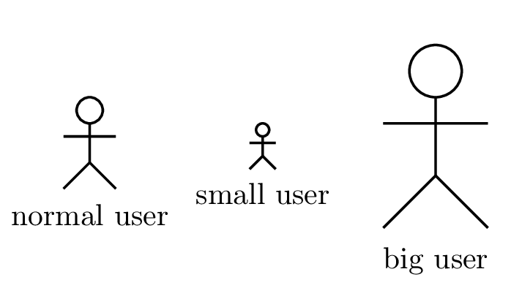



Distributor

Manufacturer



Manage Raw Materials



Customer

Admin



Supplier

Retailer

Figure 3.1 Use Case Diagram

**3**.3.1 Use Case Description

**Use Case:** Log in

**Actor:** All Actor

**Description:** All actor will log in to the system.

**Use Case:** Register Customer

**Actor:** Customer

**Description:** Customer will register to the system.

**Use Case:** Manage Raw Materials

**Actor:** Admin, Supplier

**Description:** Admin and Supplier can add, edit, and delete raw materials.

Use Case: Generate Report

Actor: Admin, Supplier, Manufacturer, Distributor and Retailer

Description: Admin can generate the report. Supplier can generate raw materials report. Manufacturer, Distributor, Retailer can generate products report.

**Use Case:** Manage Category

**Actor:** Admin, Manufacturer, Distributor and Retailer

**Description:** Admin, Manufacturer, Distributor and Retailer can add, edit and delete category of products.

**Use Case:** Manage Orders

**Actor:** Admin, Supplier, Manufacturer, Retailer, Customer

**Description:** Admin can approve and cancel all the orders. Supplier can approve and cancel manufacturer’s orders. Manufacturer can order raw materials. Retailer can approve and cancel customer’s orders. Customer can order products through website. Customer make payment if online payment. Admin, Supplier can check the payment status. Manufacturer make payment for the raw materials.

**Use Case:** Manage Customer

**Actor:** Admin, Retailer, Customer

**Description:** Admin and Retailer can see and delete the customer. Customer can edit profile.

**Use Case:** Manage Units

**Actor:** Admin, Supplier and manufacturer

**Description:** Admin, Supplier and manufacturer can add, edit and delete units of products

**Use Case:** Manage Products

**Actor:** Admin, Manufacturer, Distributor and Retailer

**Description**: Admin, Manufacturer, Retailer can add, edit, delete products. Distributor can distribute products to the retailer.

**Use Case:** Manage Users

**Actor:** Admin

**Description:** Admin will manage all the users. Admin can add, delete and edit users. Admin can give permissions to the users.

**Use Case:** Download Invoice

**Actor**: Customer, Admin, Manufacture

**Description:** Customer, Admin, Manufacture can download the invoice.

# Chapter 4. System Planning

## 4.1 Functions of the System

The function description outlines a function by detailing its possible inputs, expected outputs, and the associated database table. This concise overview provides clarity on the function's role, encompassing potential input scenarios, corresponding outputs, and the specific database table essential for its execution.

Table 4.1 Functions of the System

|  |  |  |  |
| --- | --- | --- | --- |
|  | **Functionality** | **Input** | **Output** |
| 1 | User can login by username and password. | Username and password. | Redirect to user dashboard or, show username or password incorrect |
| 2 | Admin can add, delete and edit another users. | Click on add, edit and delete button. | Message: Successful or error. |
| 3 | Admin can assign role and permissions to the user or edit them. | Role and Permissions | Message: Successful or error. |
| 4 | Admin, Supplier and Retailer can manage raw materials , products, category and units. | Click on add, delete , edit and view button. | Message: Successful or error. |
| 5 | System users can generate report. | Click on the report button. | Successfully generated report. |
| 6 | Admin, Manufacturer, Supplier and Retailer can manage stock. Admin, Supplier and Retailer can manage payment system . | Quantity, Cash on delivery or online payment | Quality updated and payment system confirmation message. |
| 7 | Admin, Supplier and Retailer can manage order. | Approve or cancel. | Successfully updated order status. |
| 8 | Manufacturer can order raw materials | Click on order place button . | Order placed successfully. |
| 9 | Manufacturer can add Distributors and delete them. | Click on ad and delete button. | Message: Successful or error |
| 10 | Distributor will get task form manufacture. | Click on task button. | Showed task details. |
| 11 | Retailer can manage product Stock. | Increase and decrease quantity | Update Stock Quantity |
| 12 | Customer can register to the system . | Profile picture , name , email , password, address etc. | Message: Successful or error |
| 13 | Customer can log in to the system by email an password. | Email and password | Redirect to the home page. |
| 14 | Customer can place the order . | Click on place order button. | Message: Successful or error |
| 15 | Customer and Manufacturer can download the invoice of order. | Click on download report button | Invoice downloaded successfully. |

## 4.2 Project Planning

Before we start a project, it's important to figure out what needs to be done, what resources we'll need, how long it will take from beginning to end, and to check if the project is doable.

In this project, we're going to follow these steps for software project planning:

* Project Estimation
* Function Related Metrics
* Process Based Estimation
* Task Distribution
* Project Schedule Chart
* Cost Estimation

#### 4.2.1 Project Estimation

The accuracy of estimating a software project relies on several factors:

* Ensuring a precise estimation of the product's size.
* Effectively translating size estimates into human effort, calendar time, and financial resources.
* Aligning the project plan with the capabilities of the software team or engineer.
* Considering the stability of both the product requirements and the environment supporting the software engineering effort.

The primary concern in my software project was accurately estimating the software size. Inaccurate size calculations could lead to various issues such as scheduling problems and budgetary constraints. Therefore, before proceeding with estimating the software size, I needed to confirm that the scope of the software was well-defined.

#### 4.2.2 Function Oriented Metrics

Function point-based estimation centers around information domain values instead of software values. The calculation of function points involves the comparison of five characteristics within the information domain.

The Domain values are:

**Functions:**

**Data**

Internal Logical File

External Interface File

**Transaction Functions**

External Inputs

External Outputs

External Inquires

**Number of external outputs** – Every user output that furnishes application-oriented information is taken into account.

**Number of external inquires** – An inquiry, characterized as an online input that leads to the generation of an immediate software response presented as an online output, is tallied for each unique inquiry.

**Number of Internal Logical files** – Every logical internal file constitutes a logical collection of data situated within the application's boundaries and is managed through external inputs.

**Numbers of external interfaces** – Every machine-readable interface employed for the transmission of information to another system is taken into consideration.

#### 4.2.3 Function Point Estimation

**Identifying Complexity (Transaction Function)**

Table 4.2 Identifying Complexity (Transaction Function)

|  |  |  |  |  |  |
| --- | --- | --- | --- | --- | --- |
|  | Transection Functions | TF | Fields/File Involvement | FTR | DET |
| **1** | User can login by username and password. | EI | Fields: username and password  File: users | **1** | **2** |
| **2** | Admin can add, delete and edit another user. And manufacturer can add Distributor and delete them. | EI | Fields: username, email, password,  address, city  File: users | **1** | **5** |
| **3** | Admin can assign role and permissions to the user or edit them. | EI | Fields: role name, permissions  File: permissions | **1** | **2** |
| **4** | Admin, Supplier and Retailer can manage raw materials , products, category and units. | EI | Fields: image, name, price, unit, category, stock, description  File: items, users | **5** | **35** |
| **5** | System users can generate report. And manufacturer , customer can download the invoice. | EQ | Fields: name, email, phone, address, product details, subtotal, shipping charge, total price  File: orders | **1** | **9** |
| **6** | Admin, Manufacturer, Supplier and Retailer can manage stock. Admin, Supplier and Retailer can manage payment system . | EI | Fields: quantity, payment status  File: orders | **1** | **2** |
| **7** | Admin, Supplier and Retailer can manage order. | EI | Fields: name, email, phone, address, product details, payment status, delivery status, subtotal, shipping charge, total price  File: orders, order details, | **2** | **11** |
| **8** | Manufacturer and customer can order items. | EI | Fields: name, email, phone, address, order id, date, payment method, products details, subtotal, shipping charge, total price  File: items, users | **2** | **12** |
| **9** | Customer can register to the system . | EI | Fields: picture, username, full name email, password, address, city, occupation  File: customers | **1** | **8** |
| **10** | Customer can log in to the system by email an password. | EI | Fields: email and password  File: customers | **1** | **2** |

**Identifying Complexity (Data Function)**

Table 4.3 Identifying Complexity (Data Function)

|  |  |  |  |  |
| --- | --- | --- | --- | --- |
|  | Data Functions | Fields/File Involvement | RET | DET |
| **1** | users (ILF) | Id , user name, email, password, address, city, role | **1** | **7** |
| **3** | items(ILF) | Id, image, material name, price, unit, stock, description | **1** | **7** |
| **4** | customers(ILF) | Id, full name , picture, user name , email ,password, address, city, zip, occupation | **1** | **10** |
| **5** | orders(ILF) | Id, name , email, mobile, address, delivery status, payment status, total price | **1** | **8** |

**Unadjusted Function Point Contribution (Transaction Function)**

Table 4.4 Unadjusted Function Point Contributions (Transaction Function)

|  |  |  |  |  |  |
| --- | --- | --- | --- | --- | --- |
| **Transection Functions** | **TF** | **FTR** | **DET** | **Complexity** | **UFP** |
| User can login by username and password. | EI | **1** | **2** | LOW | 3 |
| Admin can add, delete and edit another user. And manufacturer can add Distributor and delete them. | EI | **1** | **5** | LOW | 3 |
| Admin can assign role and permissions to the user or edit them. | EI | **1** | **2** | LOW | 3 |
| Admin, Supplier and Retailer can manage raw materials , products, category and units. | EI | **5** | **35** | HIGH | 6 |
| System users can generate report. And manufacturer , customer can download the invoice. | EQ | **1** | **9** | LOW | 3 |
| Admin, Manufacturer, Supplier and Retailer can manage stock. Admin, Supplier and Retailer can manage payment system . | EI | **1** | **2** | LOW | 3 |
| Admin, Supplier and Retailer can manage order. | EI | **2** | **11** | AVG | 4 |
| Manufacturer and customer can order items. | EI | **2** | **12** | AVG | 4 |
| Customer can register to the system . | EI | **1** | **8** | LOW | 3 |
| Customer can log in to the system by email an password. | EI | **1** | **2** | LOW | 4 |
| Total UFP= | | | | | 36 |

**Unadjusted Function Point Contribution (Data Function)**

Table 4.5 Unadjusted Function Point Contribution (Data Function)

|  |  |  |  |  |
| --- | --- | --- | --- | --- |
| **Data Functions** | **RET** | **DET** | **Complexity** | **UFP** |
| users(ILF) | **1** | **7** | LOW | 7 |
| items(ILF) | **1** | **7** | LOW | 7 |
| customers(ILF) | **1** | **10** | LOW | 7 |
| orders(ILF) | **1** | **8** | LOW | 7 |
| Total UFP = 28 | | | | |

**TDI -Total Degree of Influence**

Table 4.6 Total Degree of Influence

|  |  |  |  |
| --- | --- | --- | --- |
| **General System Characteristic** | | **Brief Description** | **DI** |
| **1** | Data communications | How many communication facilities are there to aid in the transfer or exchange of information with the application or system? | 3 |
| **2** | Distributed data processing | How are distributed data and processing functions handled? | 0 |
| **3** | Performance | Was response time or throughput required by the user? | 3 |
| **4** | Heavily used configuration | How heavily used is the current hardware platform where the application will be executed? | 4 |
| **5** | Transaction rate | How frequently are transactions executed daily, weekly, monthly, etc.? | 0 |
| **6** | On-Line data entry | What percentage of the information is entered On-Line? | 5 |
| **7** | End-user efficiency | Was the application designed for end-user efficiency? | 3 |
| **8** | On-Line update | How many ILF’s are updated by On-Line transaction? | 2 |
| **9** | Complex processing | Does the application have extensive logical or mathematical processing? | 1 |
| **10** | Reusability | Was the application developed to meet one or many user’s needs? | 1 |
| **11** | Installation ease | How difficult is conversion and installation? | 2 |
| **12** | Operational ease | How effective and/or automated are start-up, back-up, and recovery procedures? | 2 |
| **13** | Multiple sites | Was the application specifically designed, developed, and supported to be installed at multiple sites for multiple organizations? | 4 |
| **14** | Facilitate change | Was the application specifically designed, developed, and supported to facilitate change? | 3 |
| **Total Degree of Influence (TDI)=** | 33 |

|  |  |
| --- | --- |
| **Value Adjustment Factor (VAF) =** | **.65 + ( .01 x TDI ) = .65 + ( .01 x 33)** |
|  | **= 0.98** |

**Final Calculation**

Total UFP = UFP (TF) + UFP (DF)

= 36 + 28

=64

Value adjustment factor (VAF) = (0.65+ (0.01* TDI))

= (0.65+ (0.01* 3)

= 0.98

Adjusted Function Point (AFP) = Total UFP * VAF = 64*0.98 = 62.72

Effort for PHP = 53.33 * 62.72

= 3324.16 Person Hours

= 3324.16 / 8 Person Days (Working 8 Hours in a day)

= 415.52 Person Days

= 415.52 / 25 Man Months (25 working days in a month)

= 16.62 Man Months

=16.62 / 4 = 4.1

Approximately 4.1 months required for 4 persons to finish the project.

#### 4.2.4 Task Distribution/Scheduling

Project scheduling involves allocating the estimated efforts across the planned project duration. Several fundamental principles govern project scheduling:

**Segmentation:** The project needs to be broken down into manageable activities and tasks.

**Mutual Dependence**: Identify the interdependencies among compartmentalized activities or tasks. Some tasks must follow a sequential order, while others can proceed concurrently.

**Time Allocation:** Assign a specific number of work units to each task being scheduled.

**Effort Verification:** Validate that the scheduling does not exceed the allocated number of staff members available at any given time.

**Specified Roles:** Assign each scheduled task to a specific team member with clear responsibilities.

**Outcomes:** Ensure that every scheduled task has a well-defined outcome, usually a work product or a component of a work product

#### 4.2.5 Scheduling Chart

Complete system development involves a series of tasks that need to be executed in a sequential and timely manner. The project schedule generates a roadmap for the system developer.

Presented below is the schedule chart for this project:

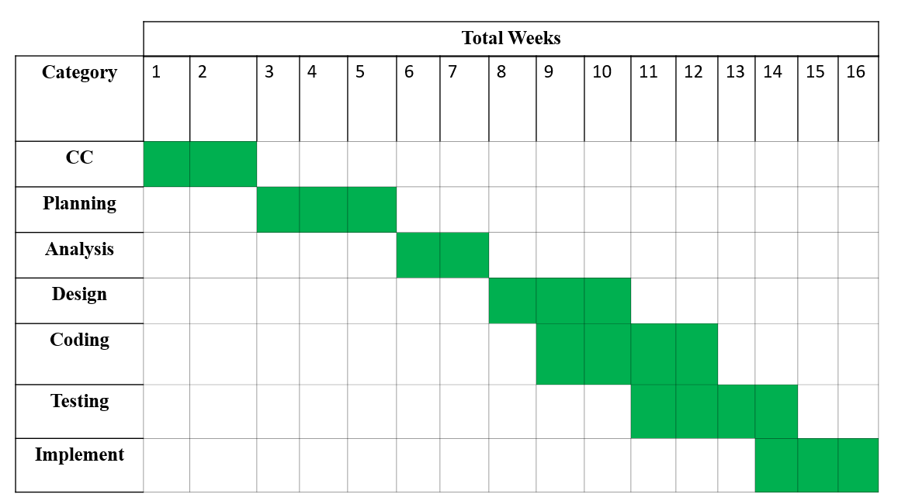Table 4.7 Scheduling Chart

#### 4.2.6 Cost Estimation

Cost estimation involves estimating the expenses associated with a program. In this project, the cost is analyzed and calculated based on five factors.

Presented below are these factors:

* Personnel cost
* Software cost
* Hardware cost
* Other cost

**Personnel Cost:**

* Total days in a year = 365 days
* Total government holidays in a year = 24 days
* Total weekly holidays in a year = 52 days
* Total working days for the project =365-(52+24) =289 days
* Working days per month = 289/12 =24.083 days
* Working hour per day = 8 hours
* Total working hours per month= 24.083*8 = 192.66 hours

Table 4.8 PersonnelCost

|  |  |  |  |
| --- | --- | --- | --- |
| **Types** | **Number of Members** | **Months** | **Salary (Taka)** |
| System Analyst | 1 | 4 | 60,000 |
| System Designer | 1 | 4 | 40,000 |
| Coder | 2 | 4 | 2,00000 |
| System Tester | 1 | 4 | 32,000 |
| **Total=** | | | 332,000 taka |

**Hardware Cost:**

Computer life = 3 year

Printer Life = 3 years

Computer usage= 16 weeks = 4 months

Table 4.9 Hardware cost

|  |  |  |  |  |  |  |  |
| --- | --- | --- | --- | --- | --- | --- | --- |
| **Computer** | **Qty.** | **Each Parts** | **Qty.** | **Price (Taka)** | **Depreciation**  **Calculation** | **Depreciation**  **Cost** | **Total Cost** |
| Desktop | 2 | Motherboard | 2 | 9,900 | 2((9,900/36)*4) | 2,200 | 6,639 |
| Processor | 2 | 11,999 | 2((11,999/36)*4) | 2,266 |
| AMD Ryzen 3  8GB RAM | 2 | 3,400 | 2((3,400/36)*4) | 755 |
| 256 GB  SSD | 2 | 2,700 | 2((2,700/36)*4) | 600 |
| Monitor | 2 | 8,000 | 2((8,000/36)*4) | 622 |
| Keyboard | 2 | 850 | 2((850/36)*4) | 188 |
| Mouse | 2 | 420 | 2((420/36)*4) | 8 |
| Printer | 1 | Printer | 1 | 19,500 | (19,500/36)*4 | 4,333 | 4,333 |
| Total=10,972 Taka | | | | | | | |

**Software Cost:**

Table 4.10 Software cost

|  |  |
| --- | --- |
| **Name** | **Price (taka)** |
| Microsoft windows 10 | 15,520 |
| Microsoft Office 13 | 15,000 |
| Visual Studio Code | 00 |
| Xampp Server | 00 |
| Total = 30,520 taka | |

**Other Cost:**

Table 4.11 Other cost

|  |  |
| --- | --- |
| **Name** | **Price (taka)** |
| Transportation | 3,000 |
| Furniture | 2,500 |
| House Rent | 40,000 |
| Electricity bill | 1,500 |
| Extra | 25,00 |
| Total = 49,500 taka | |

**Total Development Cost:**

Table 4.12 Total Development Cost

|  |  |
| --- | --- |
| **Types** | **Total (taka)** |
| Personnel cost | 332,000 |
| Software cost | 30,520 |
| Hardware cost | 10,972 |
| Other cost | 49,500 |
| **Total = 422,992 taka** | |

# Chapter 5. Risk Management

## 5.1 Risk Management Process

The process of understanding and addressing uncertainties faced by a system development team is referred to as risk analysis and management. During the development of a system, various challenges may emerge, and a risk is a potential problem that may or may not occur. Managing risks involves several steps. Initially, risks are identified, followed by an assessment of their likelihood and potential impact. Once this information is gathered, risks are documented, and a strategy is devised to address high-impact risks.

1. **Risk identification:** Risk identification refers to the activity of collecting information to recognize possible hazards or risks. Various tools and techniques are available for acquiring and processing data. The team has initiated the identification of potential threats to web resources, employing both automated and manual approaches. One notably effective technique for obtaining insights into the condition of web pages and websites is through web crawling.
2. **Risk Analysis:** The process of evaluating the probability of particular risk scenarios or sequences of events that could lead to harm or loss is termed risk assessment. Various sources emphasize risk assessment, with Rosenthal providing descriptors such as "transparent, coherent, consistent, complete, comprehensive, impartial, uniform, balanced, defensible, sustainable, flexible," and it should be accompanied by appropriate and adequate guidance when outlining the characteristics of a standard risk assessment.
3. **Risk Planning:** Risk planning is the systematic process of recognizing, evaluating, prioritizing, and formulating strategies to handle and minimize potential risks within a project or business venture. This comprehensive approach involves identifying potential challenges, developing a plan to address them, and ensuring the organization is well-prepared to navigate unforeseen circumstances. The goal of risk planning is to reduce the impact of unexpected events, enhance project resilience, and increase the probability of overall success. It encompasses the establishment of clear risk management processes, delineation of roles and responsibilities, and the formulation of effective communication strategies to adeptly manage uncertainties throughout the project's life cycle.
4. **Risk Monitoring:** Risk monitoring is the ongoing and systematic observation of potential risks within a project or business environment. It involves regularly assessing identified risks, identifying new ones, and making adjustments to mitigation strategies as needed. The goal is to ensure that risk management remains effective, enabling timely responses to emerging threats and contributing to the overall success of the project or business initiative.

## 5.2 Risk Management Implementation

The establishment of guidelines, processes, and systems to handle and respond to recognized risks is outlined in the implementation of risk management. The execution of the program should find a harmonious equilibrium between the expenses—both direct and indirect—incurred in preventing or recovering from harm or loss and the intrinsic value of assets.

**In the development of any project, it is essential to take into account various categories of risks.**

**The risks are:**

1. **Organizational risks:** These risks pose a threat to the project plan, potentially leading to delays in the project schedule and increased costs if they materialize. Risks associated with the budget, schedule, personnel, resources, customers, and requirements of the software project are collectively referred to as project risks.
2. **Technical risks:** The risks outlined pose a threat to the development of the software. If a technical risk materializes, it may become challenging or even impossible to implement the software. Technical risks involve potential issues with design, implementation, interface, verification, and maintenance
3. **People Risks:** People risks involve challenges related to team dynamics, skills variation, leadership effectiveness, and staff turnover. Managing these risks requires fostering a positive team culture, ensuring effective communication, and addressing human-centric factors for successful project outcomes
4. **Tools Risks:** Tools risks involve challenges with tool suitability, technological obsolescence, integration issues, vendor reliability, and the learning curve. Mitigating these risks requires strategic tool selection, staying updated on technology, ensuring seamless integration, and considering vendor reliability and learning requirements for the team.
5. **Requirements Risks:** Requirements risks refer to potential challenges tied to defining and managing project specifications. These risks encompass issues such as incomplete or unclear requirements, changing specifications during development, instability in project requirements, and misalignments with stakeholder expectations.
6. **Estimation Risks:** Risks from management estimates in resource allocation for system development involve uncertainties in personnel, time, and financial resources. Proactive mitigation is essential to ensure project success by effectively managing resources, timelines, and budget constraints.

## 5.3 The RMMM Plan

The RMMM plan primarily involves mitigating, monitoring, and managing project risks, considering their impact and likelihood of occurrence. They are:

* **Risk Mitigation:** Proactively planning to avoid potential risks.
* **Risk Monitoring:** Evaluating the occurrence of predicted risks, ensuring the proper application of preventive measures, collecting information for future risk analysis, and attempting to determine which risks contributed to specific issues.
* **Risk Management:** Taking actions in case mitigation steps fail and the risk becomes an active problem.
* **Impact Types:** Categorized as Catastrophic (1), Marginal (2), Tolerable (3), Critical (4).
* **Probability Types**: Classified as very low (<10%), low (10–25%), moderate (25–50%), high (50–75%), very high (>75%).

## 5.4 The Risks are:

#### 5.4.1 Technical Risks

Technical risks pose a threat to the timeliness and quality of the schedule. Given that this is my practicum project, effective management of such risks becomes imperative.

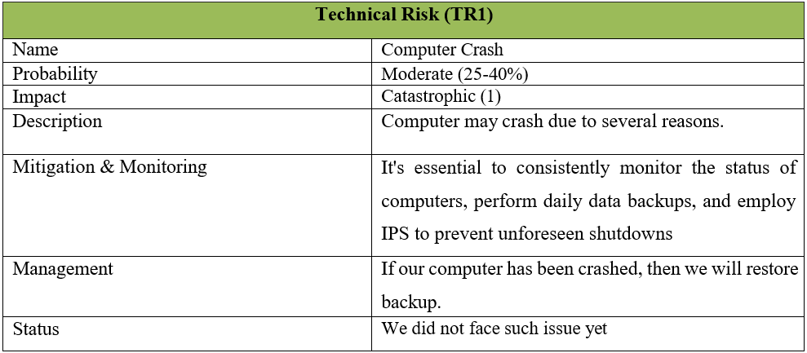Table 5.1 Technical Risk (1)

Table 5.2 Technical Risk (2)

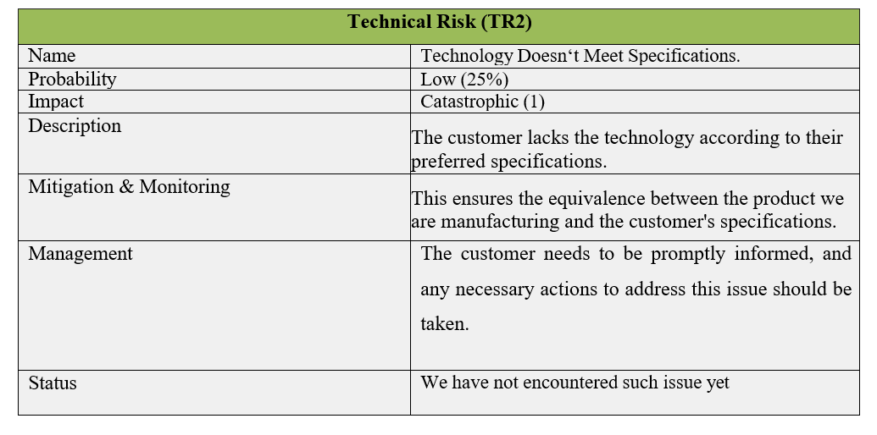

#### 5.4.2 People Risks

Table 5.3 People Risk

**People Risks**

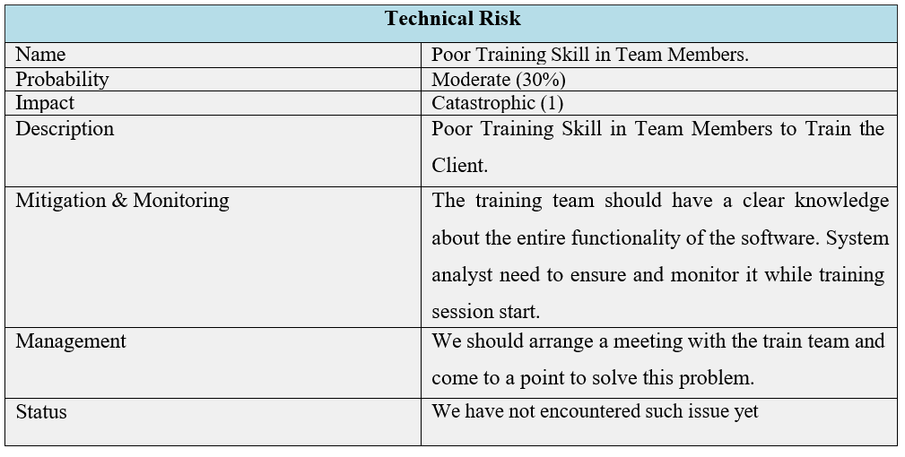

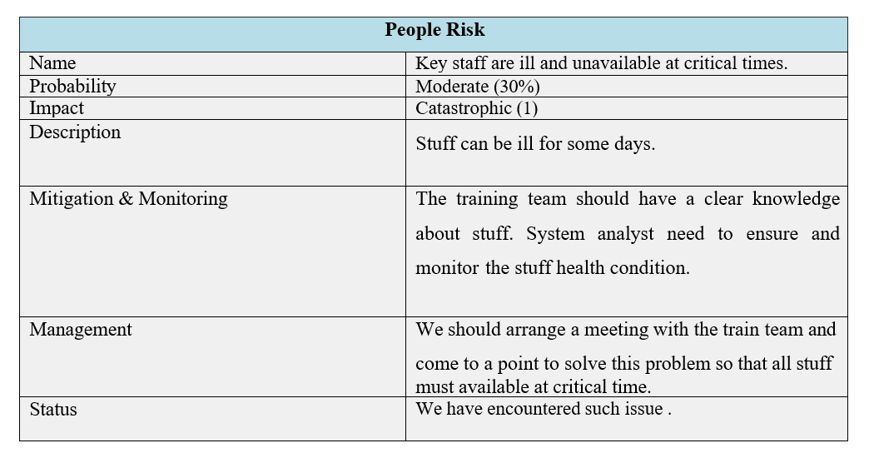Table 5.4 People Risk (2)

#### Estimation Risks

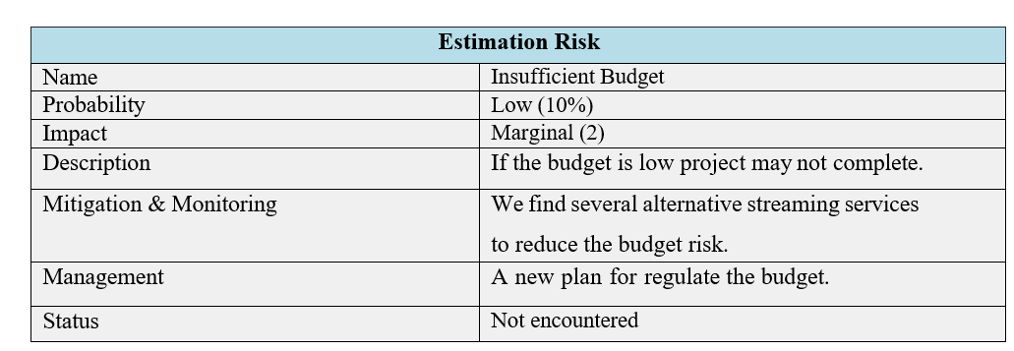Table 5.5 Estimation Risk (1)

Table 5.6 Estimation Risk (2)

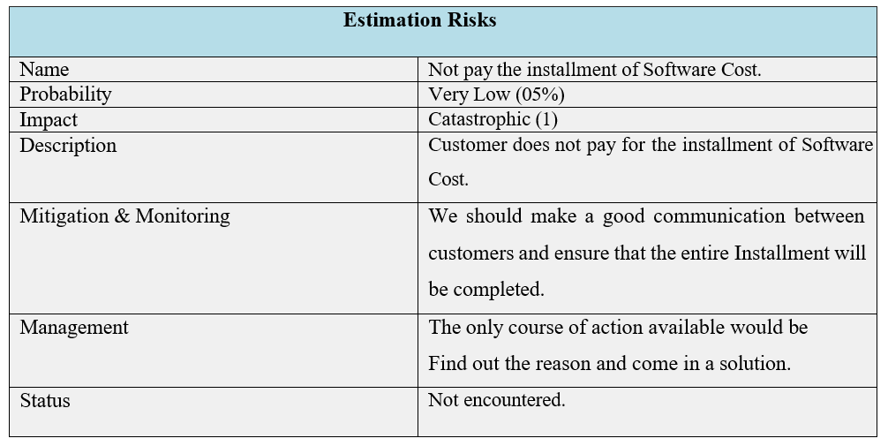

#### 5.4.4 Requirements Risks

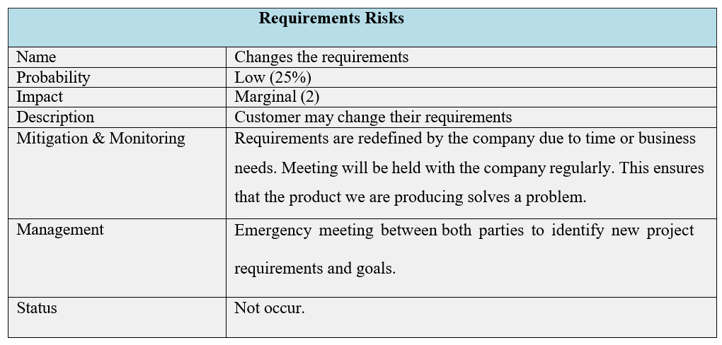Table 5.7 Requirements Risk

#### 5.4.5 Tools Risks

Table 5.8 Tools Risk

|  |  |
| --- | --- |
| **Tools Risk** | |
| Name | Lack of necessary features |
| Probability | Moderate (30%) |
| Impact | Catastrophic (1) |
| Description | The absence of essential features hinders the comprehensive functionality and effectiveness of a system or product. |
| Mitigation & Monitoring | To mitigate the impact of lacking necessary features, consider implementing regular updates, user feedback incorporation, and strategic feature prioritization to enhance functionality and address user needs effectively. |
| Management | We should use such of tools which gives majority of the features for developing the system. |
| Status | We have encountered such issue . |

# 

# Chapter 6. Analysis Modeling

## 6.1 Analysis Modeling

Analysis modeling presents requirements for data, function, and behavior in a way that is easily understandable and, crucially, straightforward to assess for accuracy, thoroughness, and coherence. This is achieved through a blend of textual descriptions and diagrammatic representations. This section includes references for UML, as well as resources for both traditional and object-oriented analysis (OOA) methods.

#### 6.1.1 Goals of the Analysis Model

* The goals of the analysis model encompass:
* Domain Analysis
* Articulating the client's needs
* Providing a foundation for software design development
* Defining a set of requirements that can be verified after the software is constructed.

## 6.2 Activity Diagram

Activity diagrams provide visual representations of workflows, featuring stepwise activities and actions with support for choice, iteration, and concurrency. They are utilized in the Unified Modeling Language to model both organizational and computational processes, offering a depiction of the overall control flow.

#### 6.2.1 Activity Diagram of Admin

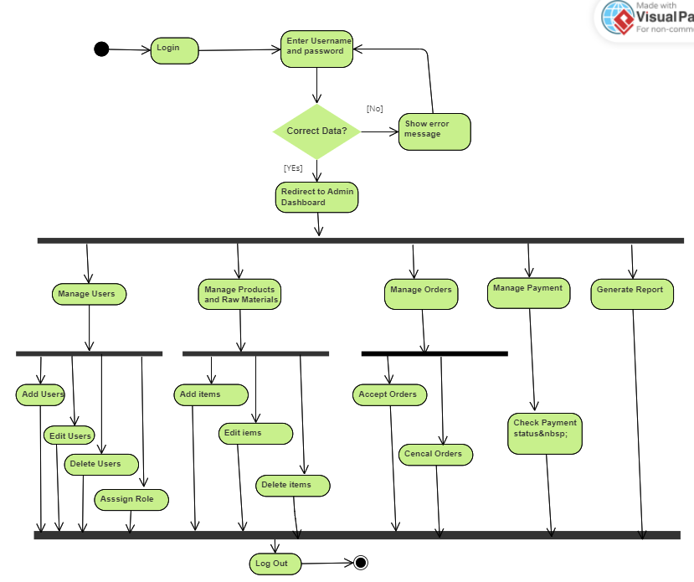

Figure 6.1 Activity Diagram of Admin

#### 6.2.2 Activity Diagram of Manufacturer

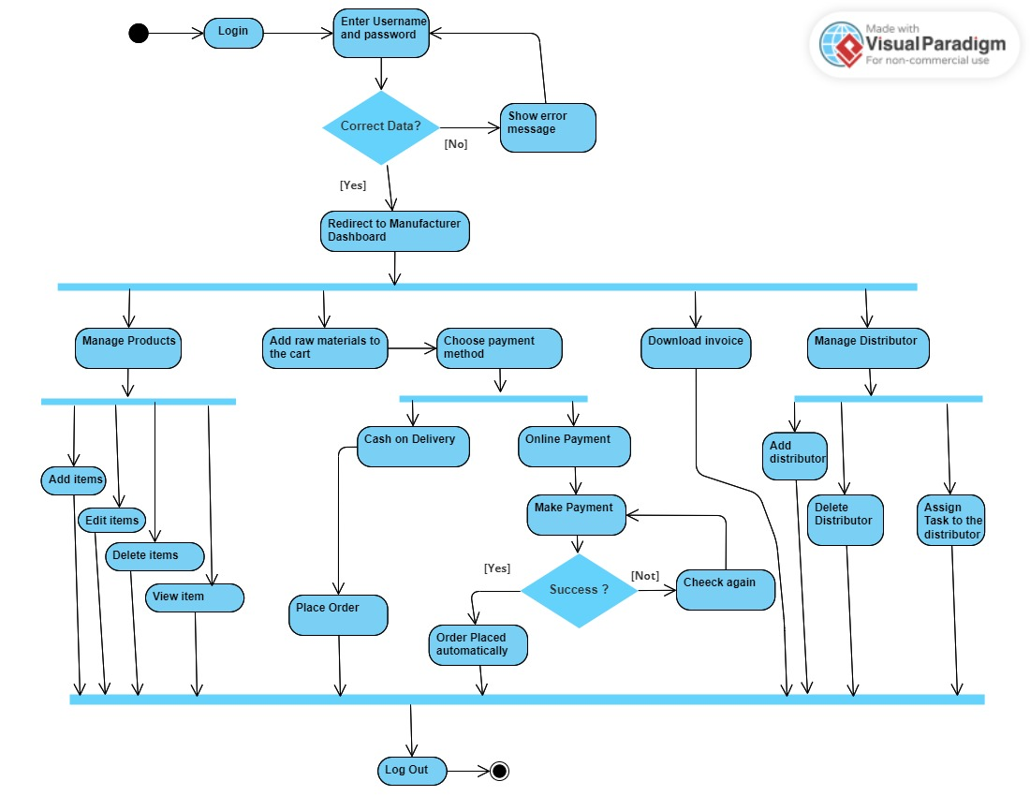

Figure 6.2 Activity Diagram of Manufacturer

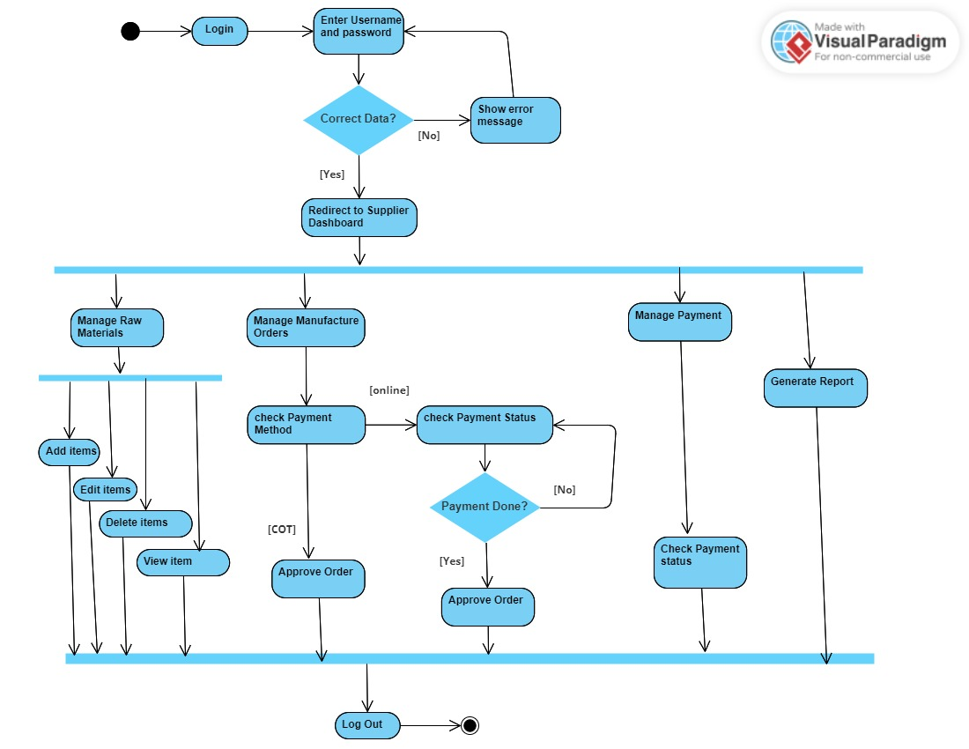**6**.2.3 Activity Diagram of Supplier

Figure 6.3 Activity Diagram of Supplier

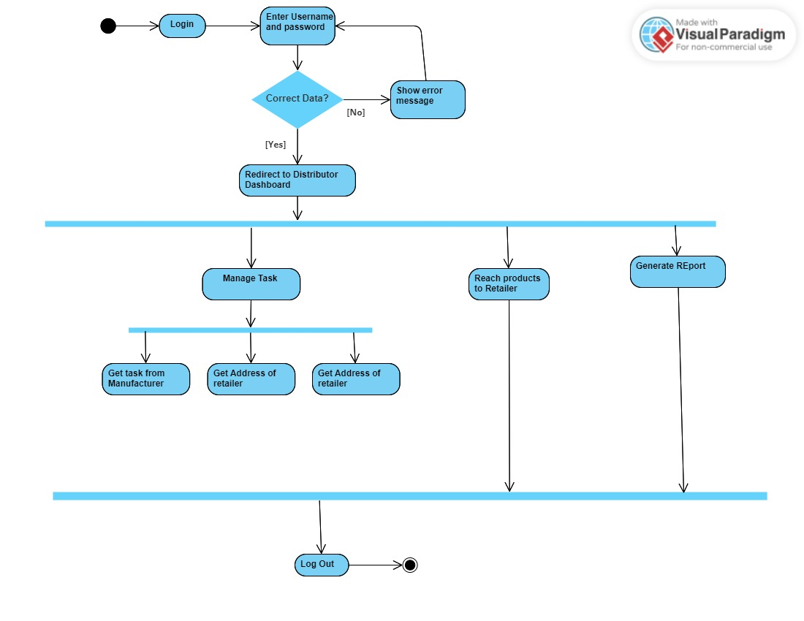**6**.2.4 Activity Diagram of Distributor

Figure 6.4 Activity Diagram of Distributor

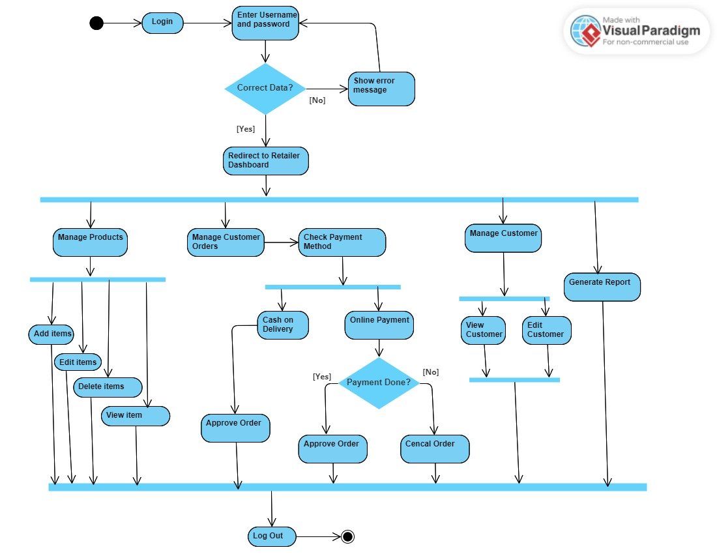**6**.2.5 Activity Diagram of Retailer

Figure 6.5 Activity Diagram of Retailer

#### 6.2.6 Activity Diagram of Customer

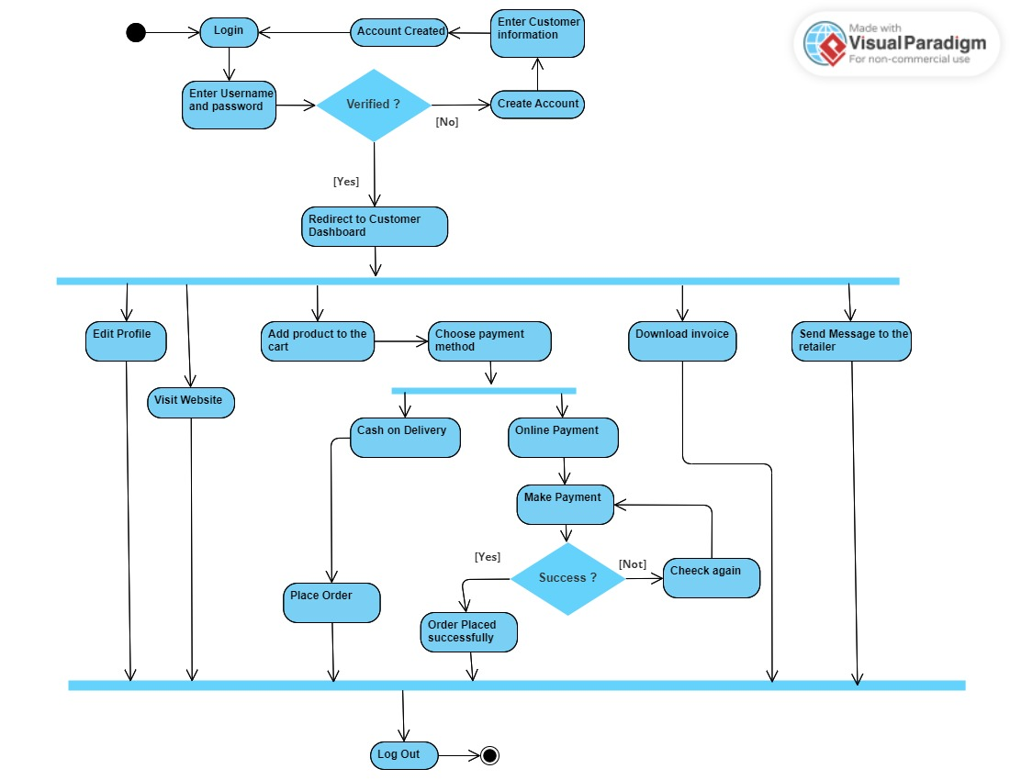

Figure 6.6 Activity Diagram of Customer

## 6.3 Entity Relationship Diagram (ERD)

An entity relationship diagram (ERD), alternatively referred to as an entity relationship model, visually illustrates the connections among individuals, objects, locations, concepts, or events within an information technology (IT) system. Employing data modeling techniques, an ERD is instrumental in defining business processes and setting the foundation for a relational database.

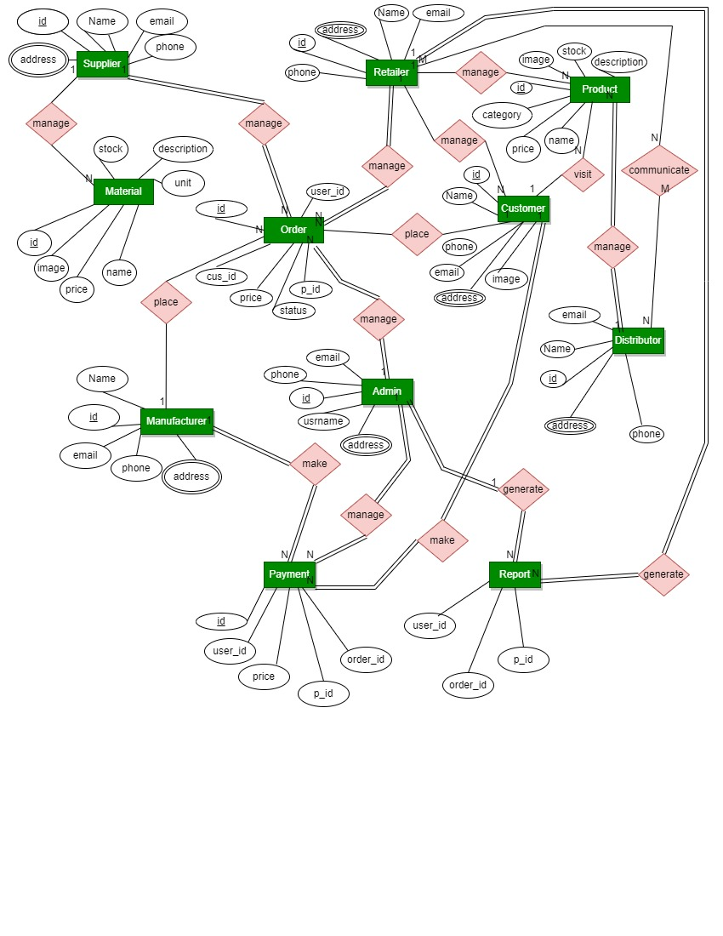

Figure 6.7 Entity Relationship Diagram

## 6.4 Data Flow Diagram (DFD)

A data flow diagram (DFD) visually portrays the movement of data within an information system, capturing the procedural aspects of its processes. Typically employed as an initial depiction, a DFD serves as the groundwork for the subsequent development of a more comprehensive system overview. Moreover, DFDs are employed for visualizing data processing procedures.

#### 6.4.1 Context Level DFD

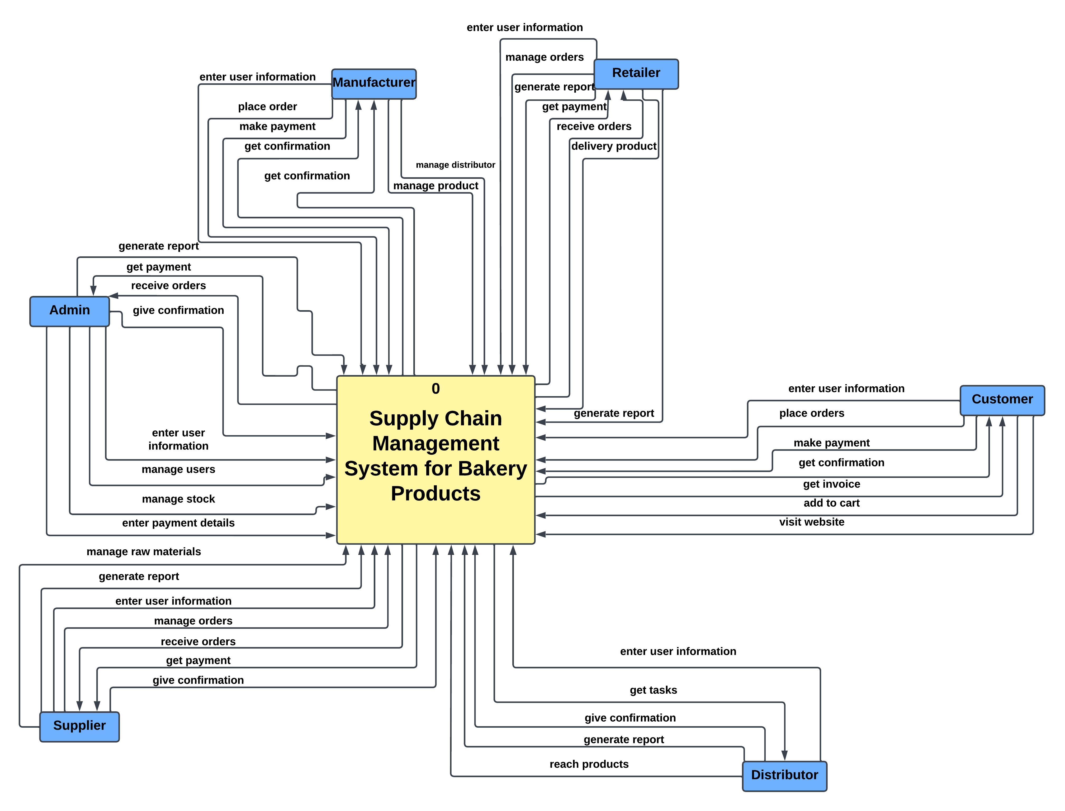

Figure 6.8 Level 0 DFD

#### 6.4.2 Level 1 DFD

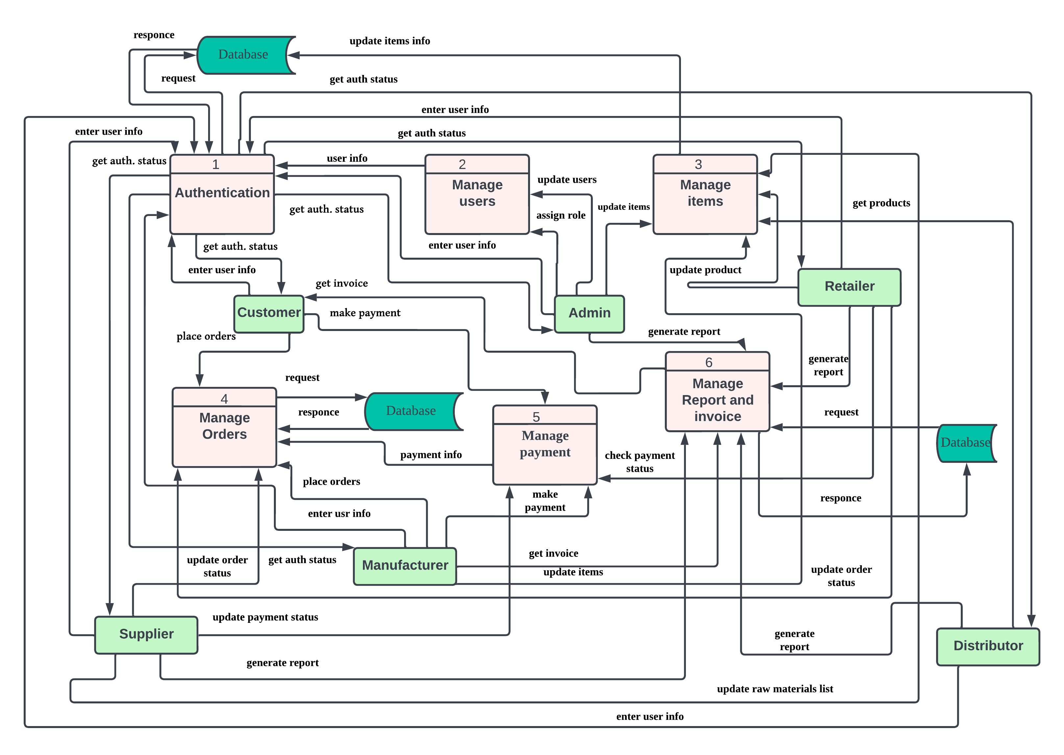

Figure 6.9 level 1 DFD

#### 6.4.3 Level 1 DFD of Process 1

Figure 6.10 Level 1 DFD of Process 1

#### 6.4.4 Level 1 DFD of Process 2

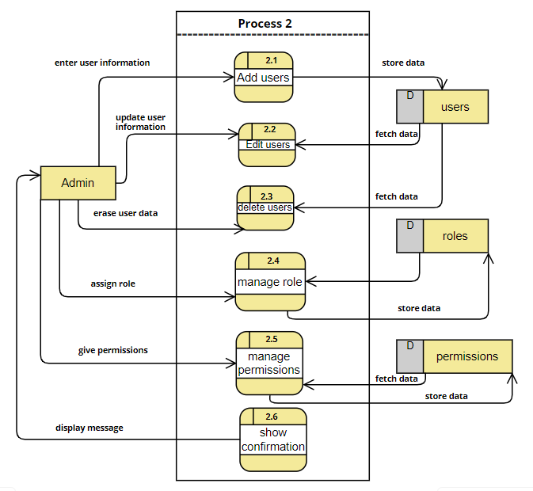

Figure 6.11 Level 1 DFD of Process 2

#### 6.4.5 Level 1 DFD of Process 3

Figure 6.12 Level 1 DFD of Process 3

#### 6.4.6 Level 1 DFD of Process 4

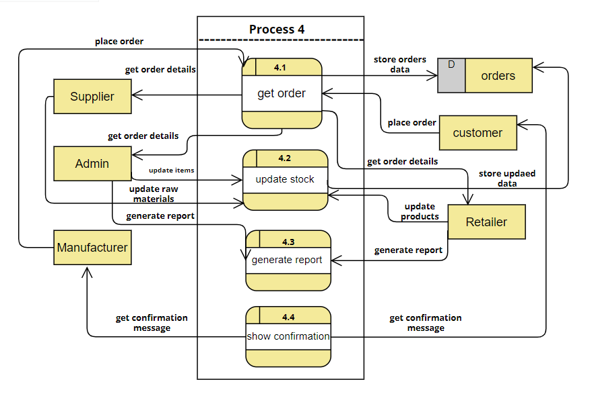

Figure 6.13 Level 1 DFD of Process 4

#### 6.4.7 Level 1 DFD of Process 5

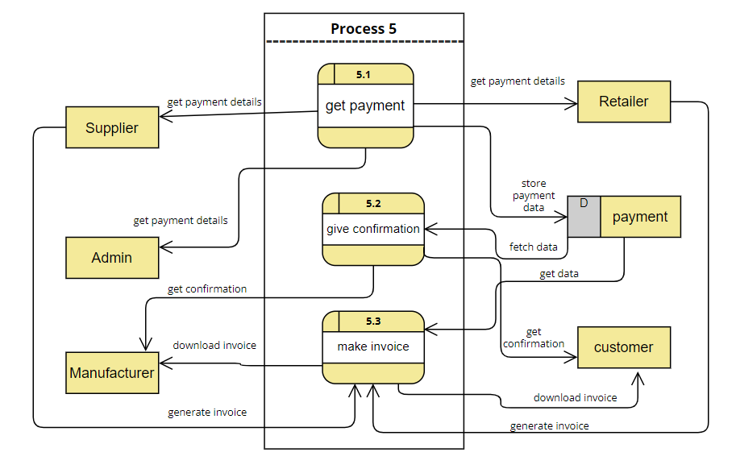

Figure 6.14 Level 1 DFD of Process 5

#### 6.4.8 Level 1 DFD of Process 6

Figure 6.15 Level 1 DFD of Process

# Chapter 7. Designing

## 7.1 Database Field Design

**Table List**

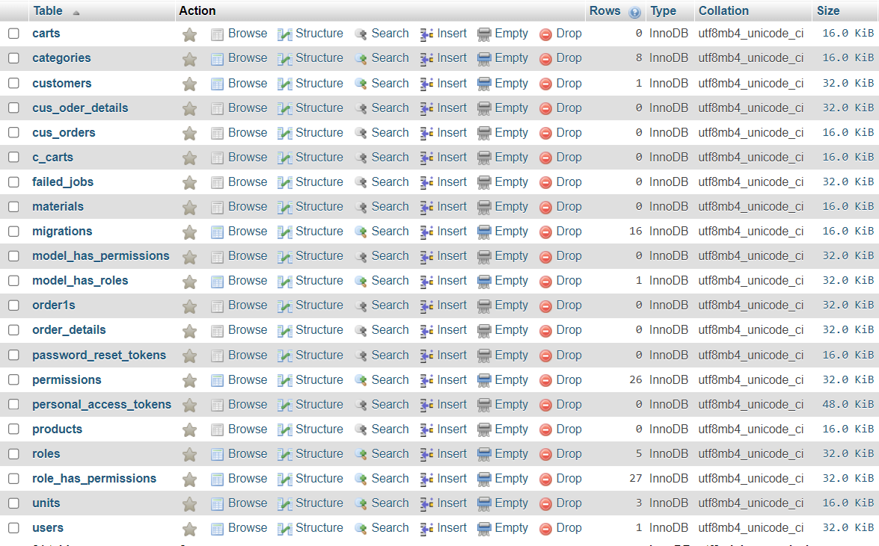

Figure 7.1 List of Database tables

**Users table**

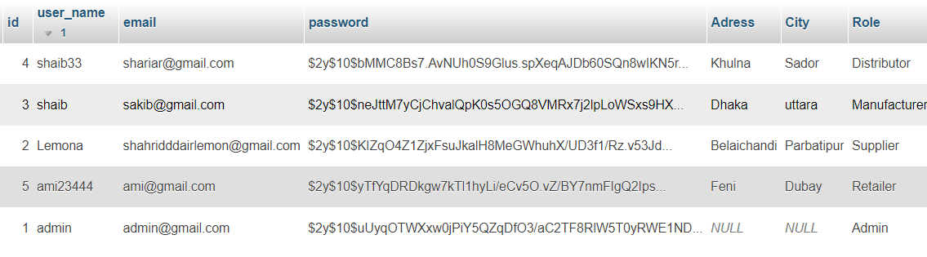

Figure 7.2 Structure of Users table

**Roles Table**

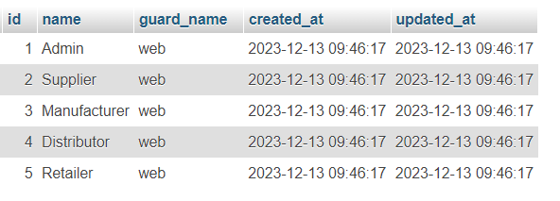

Figure 7.3 Structure of Roles table

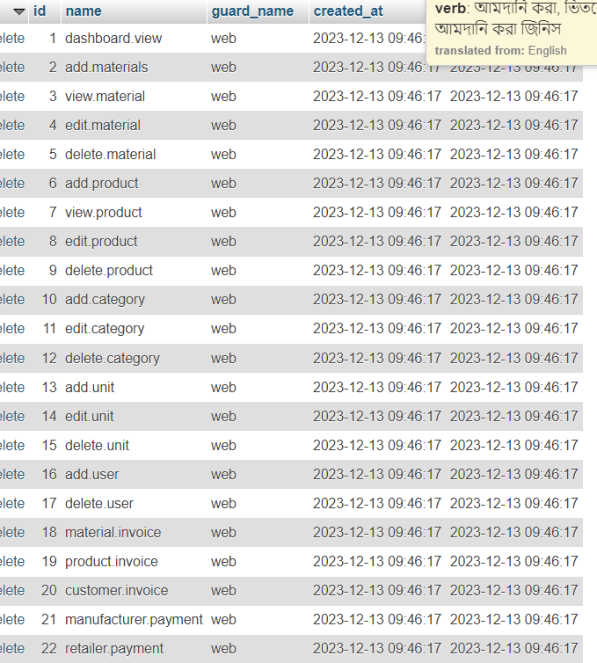**Permissions Table**

Figure 7.4 Structure of Permissions table

**Products table**

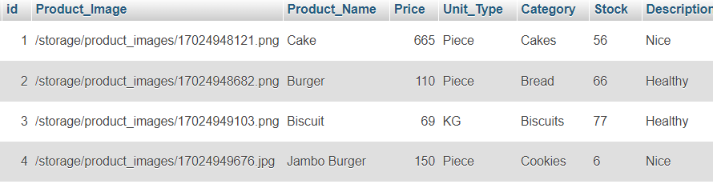

Figure 7.5 Structure of Products table

**Raw Materials table**

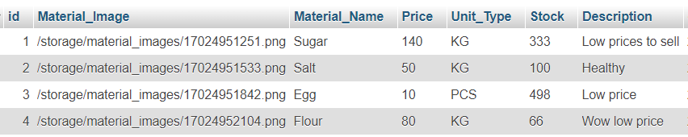

Figure 7.6 Structure of Raw Materials table

**Customers table**

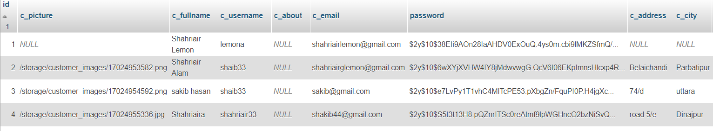

Figure 7.7 Structure of Customers table

**Carts table**

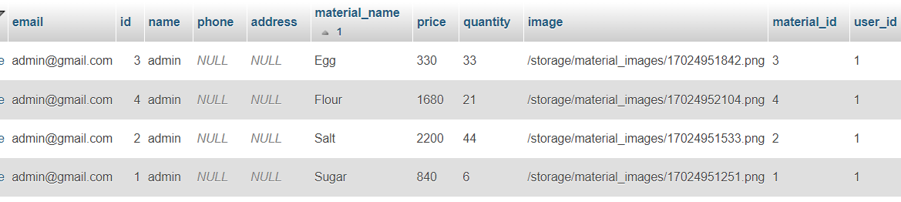

Figure 7.8 Structure of Carts table

**Orders table**

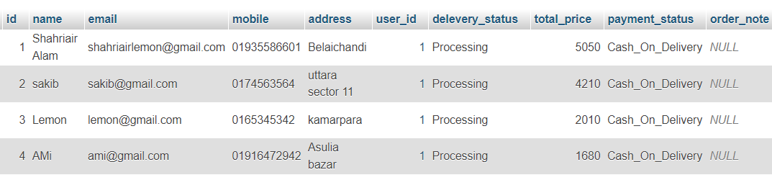

Figure 7.9 Structure of Orders table

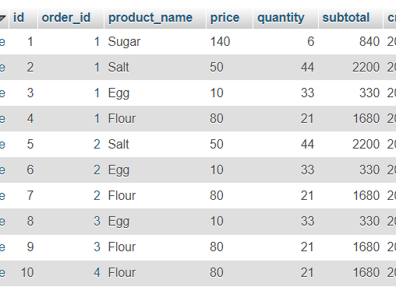**Order details table**

Figure 7.10 Structure of Order details table

## 7.2 Interface Designing

Figure 7.11 System User Login interface

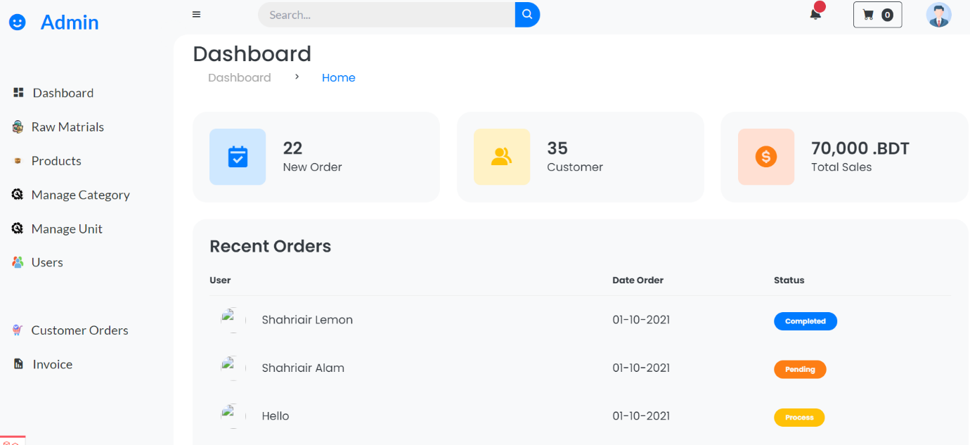

Figure 7.12 System User Dashboard interface

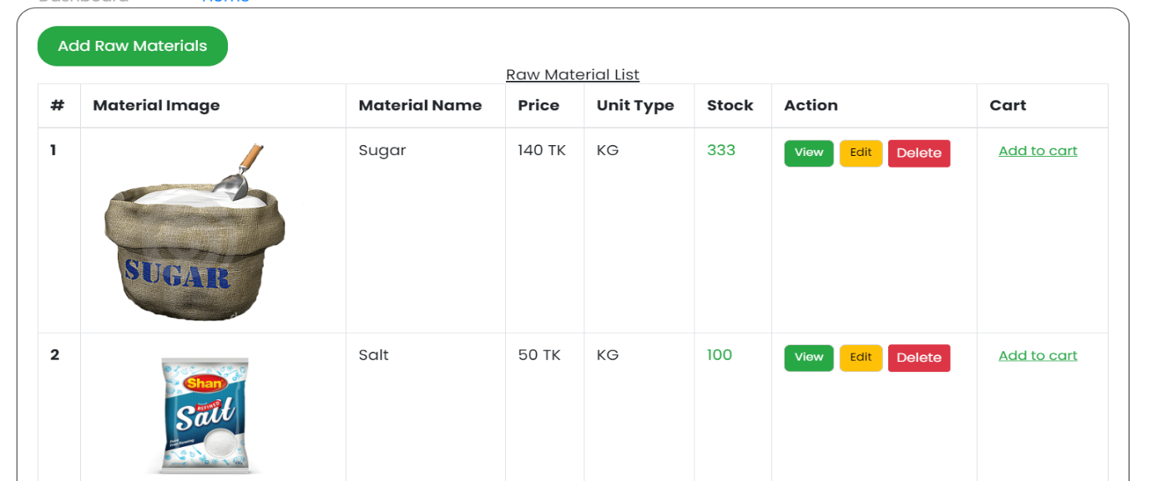

Figure 7.13 Materials page interface

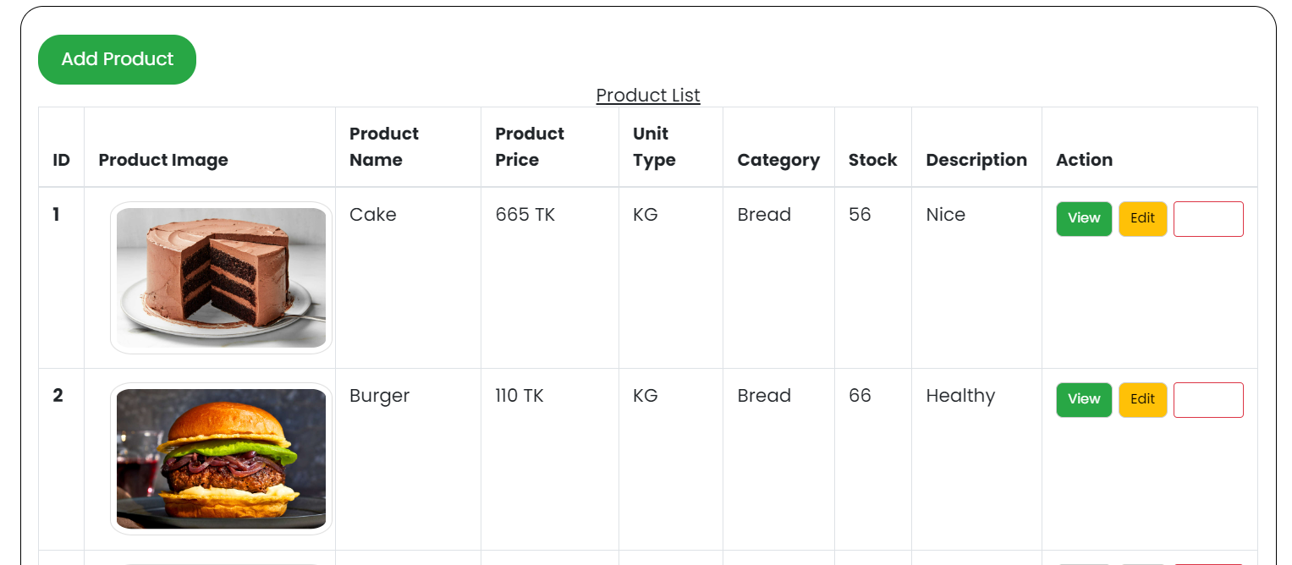

Figure 7.14 Products page interface

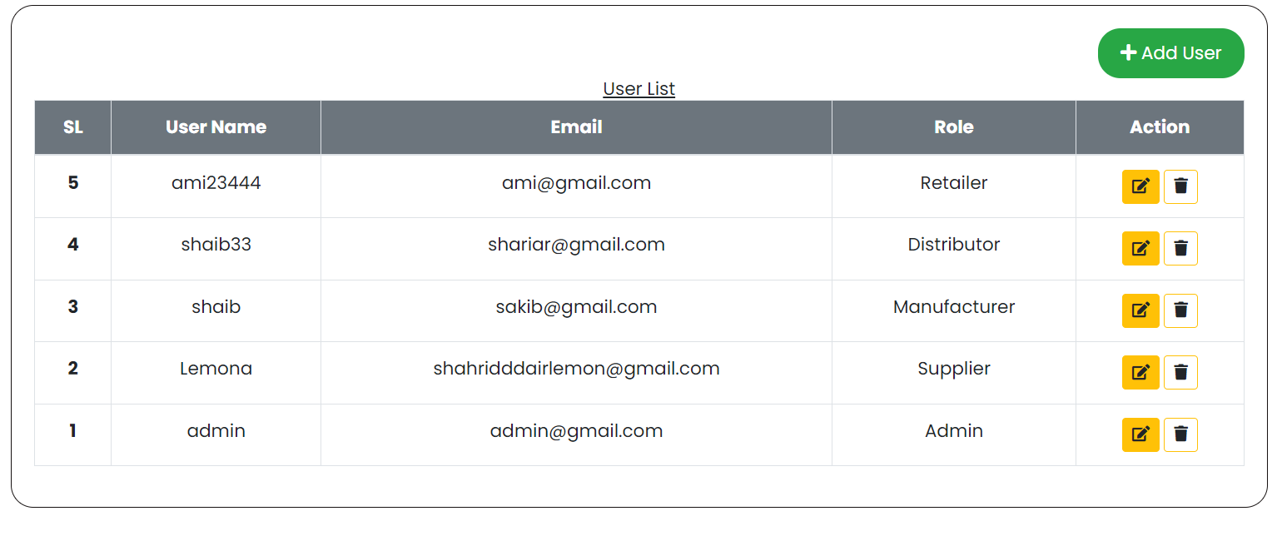

Figure 7.15 Users page interface

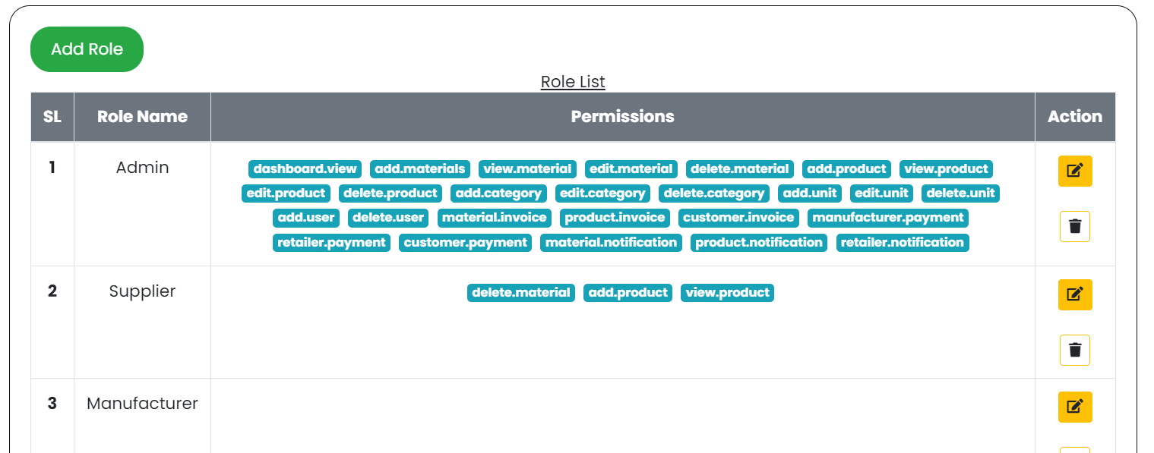

Figure 7.16 Roles and Permissions page interface

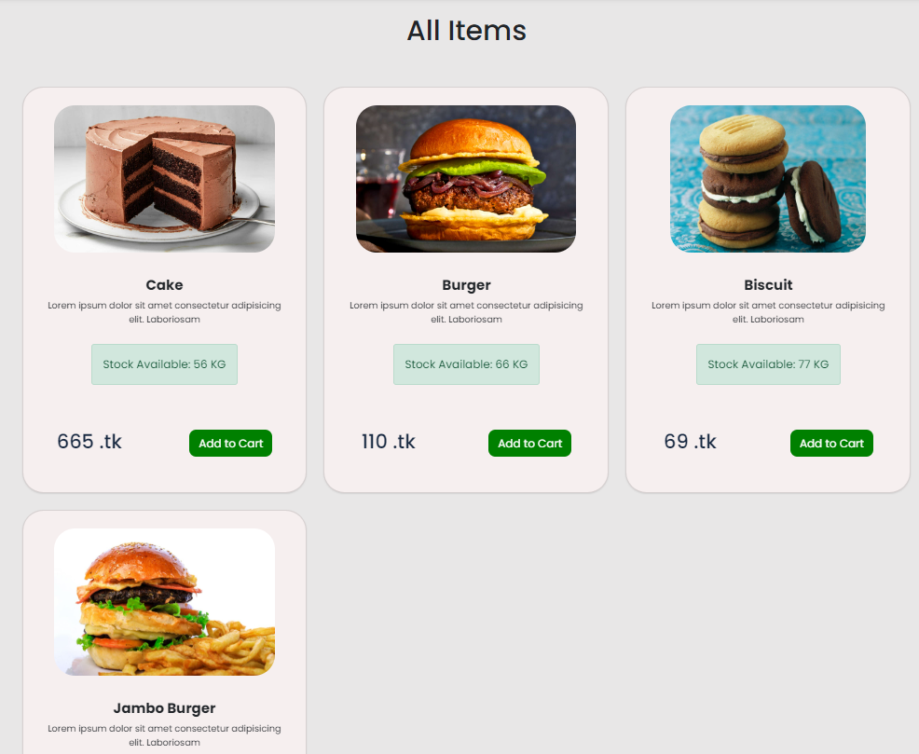

Figure 7.17 Website interface

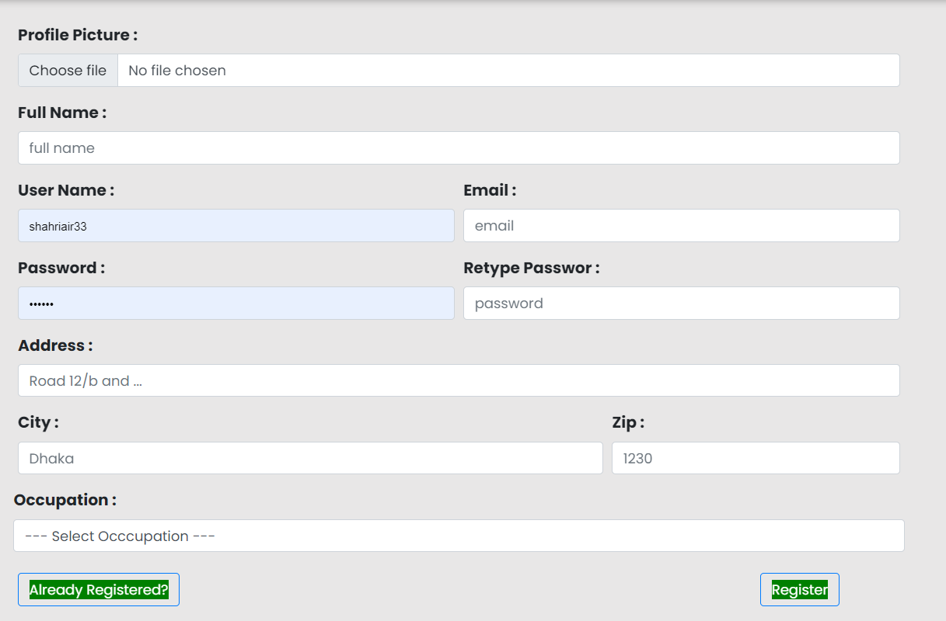

Figure 7.18 Customer Registration page interface

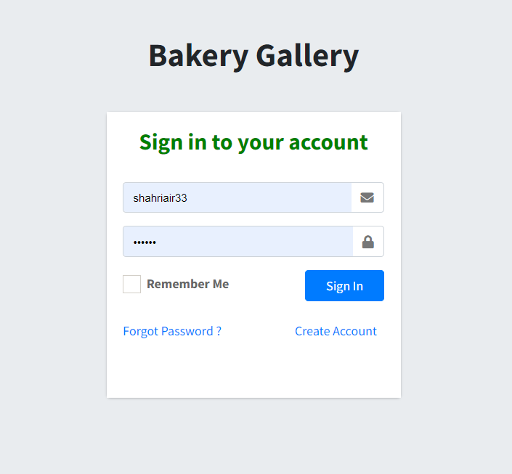

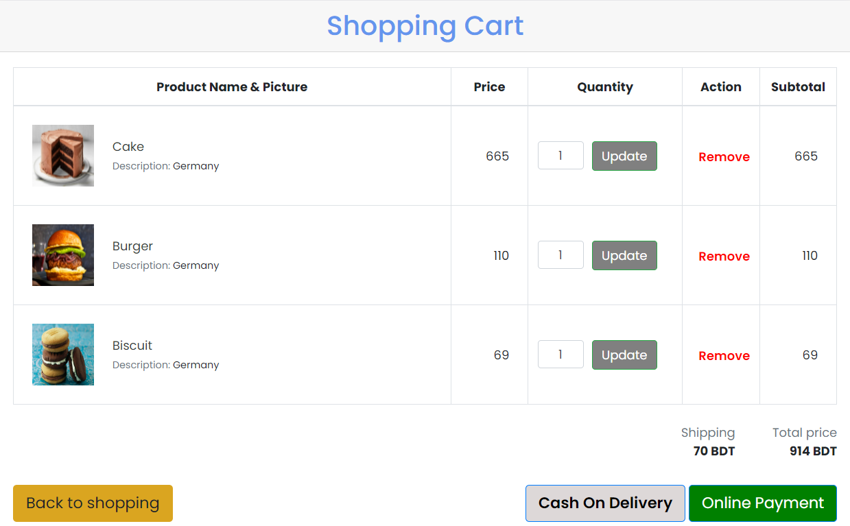Figure 7.19 Customer Log interface

Figure 7.20 Shopping Cart interface

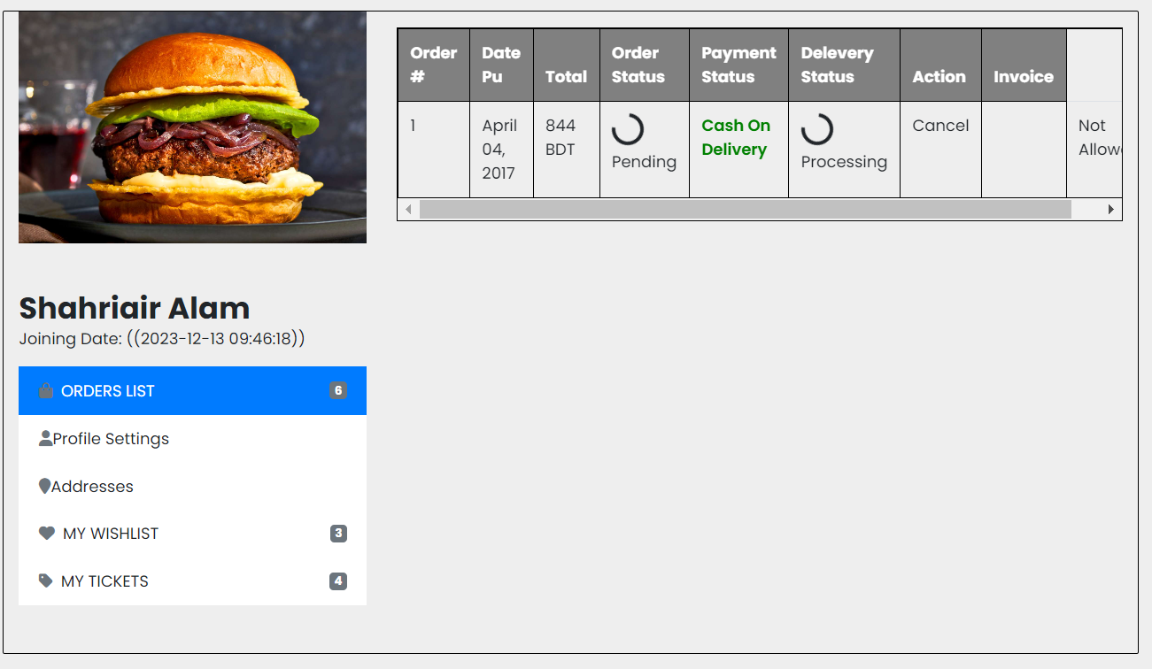

Figure 7.21 Customer profile interface

# Chapter 8. Quality Assurance

## 8.1 Software Testing

Software testing involves evaluating a software item to identify discrepancies between provided input and anticipated output, as well as examining the characteristics of the software item. It aims to gauge the quality of the product and is an integral part of the development process, serving as a verification and validation process.

**Verification and Validation process**

During the verification phase, the client has the choice to either inspect the program or observe its performance in a test environment. It is essential for the client, with specific software requirements and expectations, to confirm that the product aligns with the initially specified characteristics. Only after obtaining this assurance should the subsequent steps in the verification and validation process proceed. While this phase does not represent the final opportunity for adjusting the program to meet its intended functions, it does signify one of the last stages before project completion. Hastily approving the software at this point may lead to potential issues later, requiring additional expenses for future software revisions.

The purpose of a system audit is to provide an impartial assessment of compliance with running laws, standards, guidelines, plans, and procedures concerning software products and processes. This audit follows a formally structured approach, with participants assuming designated roles such as lead auditor, auditor, recorder, initiator, and a representative from the organization under audit. The audit aims to identify instances of nonconformance and generate a report that necessitates corrective measures to be implemented by the team.

## 8.2 Software Testing Strategy

**Black box testing:** Black box testing doesn't require an in-depth understanding of the internal architecture or knowledge of the code; it primarily focuses on functionality, specifications, and requirements. Conversely, white box testing involves a comprehensive understanding of the core design and code, subjecting specific code statements and coding styles to tests.

**Unit Testing:** Unit testing examines specific functions or code modules at the smallest scale and is typically conducted by the programmer due to its requirement for a thorough understanding of the internal program architecture and coding.

**Incremental integration testing:** Incremental integration testing involves testing a program regularly as new features are added. Different aspects of the application's functionality must be sufficiently independent to work individually before all sections of the programmer are completed or test drivers are produced, with programmers or testers overseeing this process.

**Functional Testing**: Functional testing, focusing on an application's functional requirements, is performed using black box testing. Software testers are typically responsible for this, although programmers should also test their code before release.

**System testing:** System testing, conducted in a black box, is based on overall requirements specifications, encompassing all components that constitute a system. End-to-end testing is similar to system testing, involving putting the entire application environment through its paces in a real-world setting, potentially interfacing with databases, communicating across networks, or interacting with other hardware, software, or systems.

Load/stress/performance testing evaluates how well an application handles substantial loads, simulating high-traffic situations to identify when the system starts to fail or cause problems.

**Usability testing:** Usability testing assesses whether a program is user-friendly and is determined by the client or user through methods such as interviews, surveys, video recordings, etc. Programmers and testers are generally unsuitable for the role of usability testers.

**Security Testing:** Security testing evaluates how effectively a system protects itself from illegal access, both internally and externally, as well as malicious damage, possibly requiring advanced testing procedures.

**Compatibility testing:** Compatibility testing assesses the software's performance in various environments, including hardware, software, operating system, and network environments. For instance, testing a website in different browsers and browser versions.

## 8.3 Testing Design

Table 8.1 Testing Scenario 1

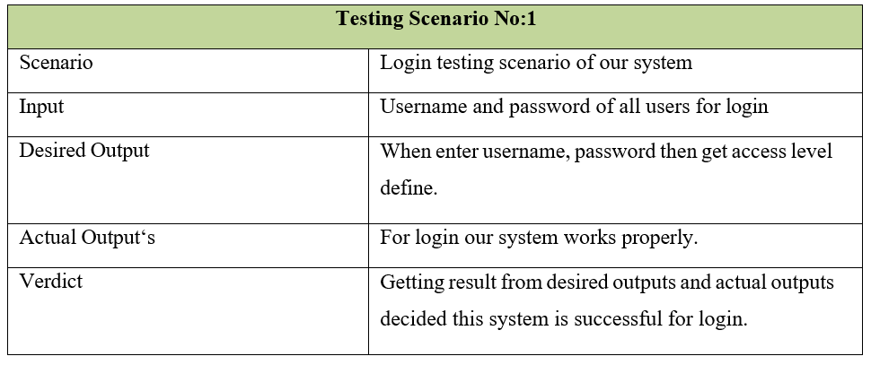

Table 8.2 Testing Scenario 2

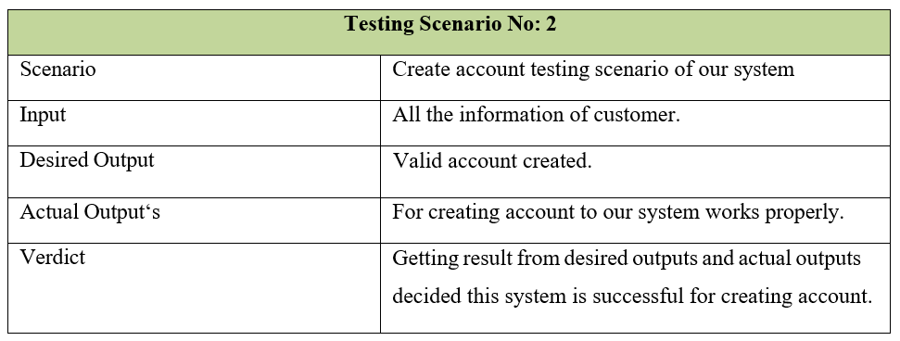

Table 8.3 Testing Scenario 3

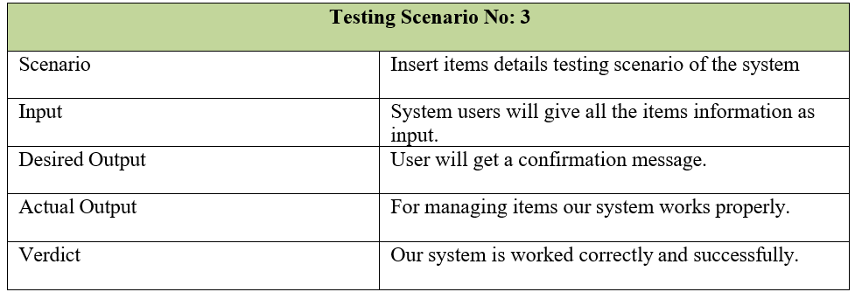

Table 8.4 Testing Scenario 4

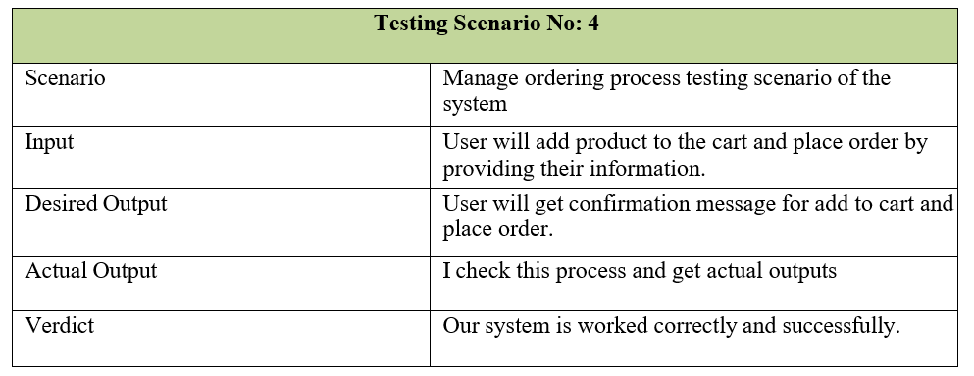

Table 8.5 Testing Scenario 5

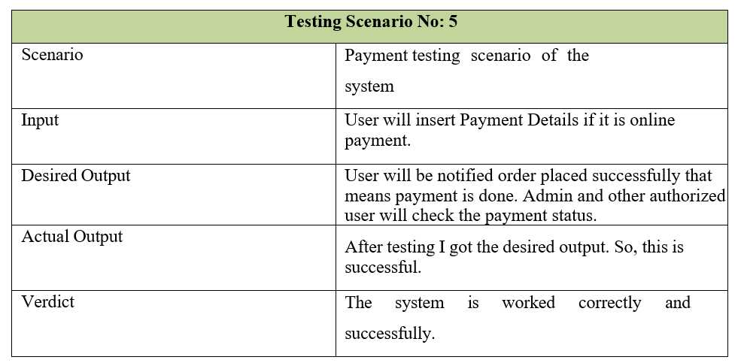

Table 8.6 Testing Scenario 6

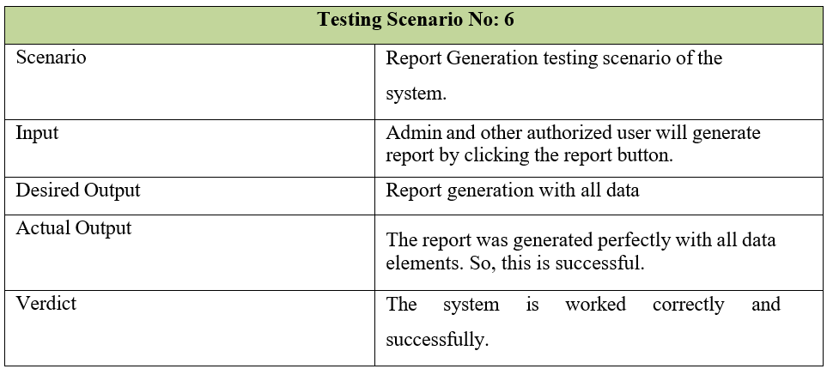

# Chapter 9. Conclusion

## 9.1 Preface

Today is the age of modern science and information and online communication, which is critical to development of more effective operational and management process. To provide better and uninterrupted services to the employee of Kodeeo Limited a group of Software specialist working together to keep the service all time. I was fortunate and blessed to get this lucky break to work some of these efficient hard working friendly engineers. My earnest thanks, gratitude and salutations to these wonderful people from the deep down inside my heart.

#### 9.1.1 Practicum and Its Value

Working hard in your job can help you move up, just like putting in effort in other parts of life. We think that doing a hands-on program called a Practicum can link what you learn in engineering college to real-world jobs.

Doing a Practicum has many good points for students:

* It shows how to use what you learn in a practical way.
* It helps you get better at things in the area you're studying.
* It makes you more likely to get a job.

Practicum is not just about getting hands-on experience; it also helps you fit in better with society. Meeting new people and trying new things gives you a practical view of life. There are some challenges during a Practicum that you can only understand if you go through them.

This program connects what you learn in school with real-world skills, helping you start a professional career. Nowadays, companies that hire engineers like it when you have practical experience more than just good grades. So, doing a Practicum can be an advantage for new engineers looking for a job.

At the College of Engineering and Technology (CEAT) at IUBAT, students do this Practicum program for one semester, after they finish their regular classes. They work on it for 6 credit hours, and after completing it, they write a report, do a presentation, and take a big test covering everything they learned in the four years of their education.

## 9.2 Conclusion

My internship at Kodeeo Limited has been an incredible experience. In just 12 weeks, I've learned a lot that will have a positive impact on my future career goals. During this internship, my assignment was to complete a project called "Supply Chain Management System for Bakery Products." This report provides detailed information about the project, including its development phases and strategies.

Supply Chain Management System for Bakery Products is a system designed to efficiently manage the production and delivery of bakery products, optimizing processes and ensuring quality. Implementing an effective Supply Chain Management System for bakery products in Bangladesh holds great promise for enhancing efficiency and ensuring the consistent delivery of high-quality goods. The adoption of advanced technologies and streamlined processes can address existing challenges within the supply chain, promoting cost-effectiveness and operational excellence. Collaboration among key stakeholders, including suppliers and distributors, is essential for the successful integration of this system. Regular monitoring and evaluation will be crucial to identify areas for improvement and ensure the sustained success of the bakery's supply chain. By embracing these advancements, bakeries in Bangladesh can position themselves for long-term success, contributing to the growth of the industry while meeting the demands of a dynamic market.

Throughout the project development, I encountered various challenges, with the most significant being the constraint of time. The time limitation imposed several constraints on the project. Should I be afforded the opportunity to continue working on this system, I have comprehensive plans to transform it into an ideal "Supply Chain Management System for Bakery Products."

## 9.3 Limitations

Due to time constraints, constructing an ideal system proved challenging, resulting in several limitations within the "Supply Chain Management System for Bakery Products."

The limitations are:

* There is no shipping option for every chain. Shipping facility is available only for customer.
* There is no option for live customer support.
* It might struggle if the bakery gets a lot bigger or if things change a lot.
* There is no mobile OTP verification.

## 9.4 Future Plan

If I get to keep working on this project, I have ideas to make it work better for everyone.

The followings are the future plans:

* I will make the shipping facility for every chain in this system, not only for the end user.
* I will keep live customer support.
* If the bakery size is bigger then I will change the functionality so that it works fine for the large data. Also I will change my database server.

# Glossary

ERD- Entity Relationship Diagram

DFD- Data Flow Diagram

DF-Data Function

DET-Data Element

DB- Database

EI-External Input

EO-External Output

EIF-External Interface File

ILF-Internal Logical File

RET-Record Element

TF-Transactional Function

VAF-Value Adjustment Factor

# References

* Pressman, Roger S.( 2004) Software Engineering: A Practitioner’s Approach. 5th ed. Boston:McGraw Hill
* Pressman , R. S. (2016). Software Engineering. Singapore: McGraw-Hill.
* Kendall, E. Kendall. ( 1999) System Analysis and Design. 4th ed. New Delhi: Prentice Hall.
* O’Brien, James and M. Markas, George (2008). Management Information System. 8thInternational ed.
* Shriram, R.B., Nandhakumar, P., Revathy, N. and Kavitha, V., 2019. House (Individual
* House/Apartment) Rental Management System. International Journal for ComputerScience and Mobile Computing, 19, p.143.
* Steiniger, S., Neun, M. and Edwardes, A., 2006. Foundations of location based services. LectureNotes on LBS, 1(272), p.2.
* O'reilly, T., 2007. What is Web 2.0: Design patterns and business models for the next generation
* of software. Communications & strategies, (1), p.17Miller, Dave.(2006) Data Communication and Networks. 1st ed.
* S. Pressman, Roger, (2008) Software Engineering A Practitioner’s Approach, 6th edition
* Richard H. (2011) Software Requirements Engineering, 2nd Edition